Apple Pie Bites

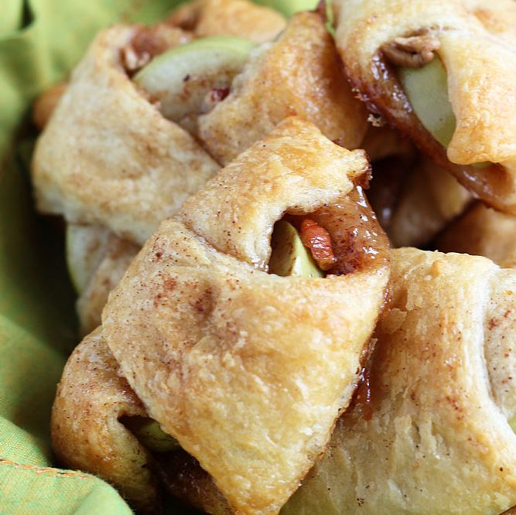

This recipe makes 8 apple pie bites

What you need

- 55g light brown sugar
- 1 teaspoon of mixed spice, and extra to sprinkle on the top of the bites
- 3 tablespoons butter, melted
- 40g chopped pecan nuts
- 1 small apple, cored and sliced into 8 ½ inch slices
- 1 pack jus-rol croissants (you can buy these from most supermarkets)

What you do

- Preheat your oven to 190c, gas mark 5. Line a baking tray with baking paper
- In a small bowl, combine sugar and mixed spice, set aside
- Melt butter and toss apple slices in the melted butter, set aside
- Arrange readymade croissant triangles on the baking tray. Evenly distribute brown sugar mix onto each triangle
- Sprinkle each triangle with the chopped pecans
- Place an apple slice on the wide end of each one. Wrap the dough around each apple
- Brush each on with the remaining butter. Sprinkle lightly with additional mixed spice
- Bake for 10 -12 mins, or until golden brown. Cool for 5 minutes before serving

