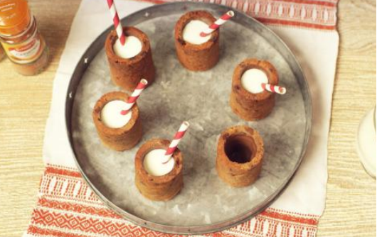

Chocolate Chip & Ginger Cookie Cups
What you need:
- 200g solid vegetable fat
- - 100g light brown sugar
- - 50 g caster sugar
- - 1 medium egg, beaten
- - 1tsp vanilla extract
- - 250g plain flour, sifted
- - ½ tsp salt
- - 1 tbsp Schwartz Ground Cinnamon
- - 1 tsp Schwartz Ground Ginger
- - 100g small milk chocolate chips
- - 150g milk chocolate
- - milk, to serve
What you do:
In a large bowl, beat the vegetable fat and sugars until light and creamy. Add the egg and vanilla and mix until combined. Add the flour, ½ tsp salt and spices, beating until you have crumbly dough. Stir through the chocolate chips.
Fill an oven-proof shot glass mould with the dough, packing it right to the bottom and pressing down firmly to eliminate any air bubbles. Make sure to cover the tops of the raised parts of the mould with dough slightly below the top of the cavity. Refrigerate for 30 mins to firm up.
Heat oven to 190C/170C fan/gas 5. Bake the cookie shots for 30 mins and allow to cool completely before carefully turning out of their moulds.
Melt the chocolate by putting it in a small bowl set over a pan of simmering water. Pour a spoonful of chocolate into a cookie shot and swirl around the inside wall of each cookie. Pour out any excess.
Refrigerate to set, then fill with milk and serve with a straw.

