DIY Painted Feathers

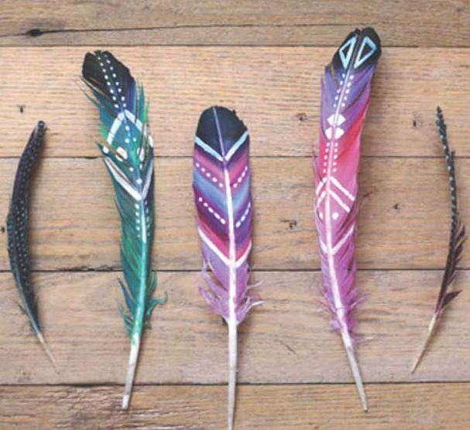

What you need:
- Acrylic paint
- Paint brush
- Feathers

What you do:

- Pick your colours and put a small amount of each in a nice clean surface.
- Dip your brush in the first colour that you want and start painting. Continue painting with the colour combination that you like. Be creative!
- Let the paint dry and prepare your black and white paint to add some design.
- Let the paint dry and prepare your black and white paint to add some design.

