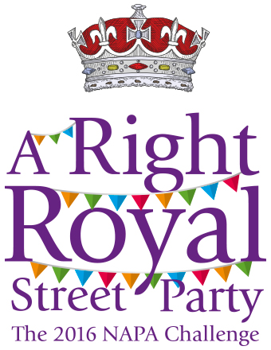
Getting the Community into Care Settings for your
Right Royal Street Party.

Your chance to win £1000

The new style NAPA Challenge 2016 will give every care setting the chance to win £1000 to spend as they choose.
To enter you simply need to hold a Right Royal Street Party on the 12th June and send us a photo – no writing necessary.

All entries will be put into a draw and the winner will be invited to the NAPA Gala to collect their cheque!
Further details are in this issue of Living Life.

Why should you?
Because everyone who works in care needs to help the general public to see what great places care settings can be. Places that support the frailest or dependent elder people to experience a better quality of life than they might have elsewhere. Places that offer compassion and care. Places that enable people to live life the way they choose with meaning and purpose.
We also need to help older people to view care settings as great places. We need to help them overcome some of the misconceptions and myths that fuel fear and anxiety about moving into a care setting.
We know that word of mouth is the best way to get good news out. We want to offer lots of opportunities for the community to experience the great atmosphere in good care settings and to go away and tell others about it.
Targeting people with influence in the community, like councillors and MP's, means that the 'word of mouth' might spread even further.

Many of you will already have strong links with the local community and will be used to hosting events in which case your challenge will be to extend your connections to groups or individuals that know nothing about your care setting. For some homes this will be a new venture so we’ve detailed some ideas to get you thinking.

Where to start?
Think about what you want to do on Sunday 12th June,for your Right Royal Street Party. What are you good at? What do your residents really enjoy? What creates the best atmosphere in your home? How can you extend this activity to include guests?
Unless you really enjoy a challenge it pays to stick with a formula that you know works.

If you have never done something like this before then just one event on the day might be your target. If you have very limited space or facilities you might consider setting up an event away from the care home, the next street perhaps, where some residents and local residents can have a joint street party together.

Who to involve?
It will be important to involve residents, relatives and staff in the planning from the outset. People will enjoy it much more if they feel it is their own event rather than one imposed on them. If they are enjoying it the visitors will too.

The following questions might help you decide what to do, when and where.

Think about the environment.

Where is it possible for people to gather together?
What numbers can you realistically cater for at any one time?
What routes through the home can you signpost that will keep everyone safe?
What toilet and cloakroom facilities can you use?
If you are using an outdoor space, what is your wet weather plan?
Do you have some intimate spaces for smaller groups?

Think about resources

Do you have the specialist equipment you need for what you want to do?
Can you arrange for extra staff to be on duty that day?
Do you have a budget for the day?
Do you have enough furniture for extra visitors?
Can the catering team support your plans?
If you are planning something outdoors can you provide shade or shelter?
Who can help you with producing publicity materials?
Can you make time to get out and meet community group leaders face to face to get their support?
Do you have access to a phone for contacting people during the working day?
Do you have access to a PC for contacting people?
Could you use Twitter or Facebook to contact relatives and get them to help?

How do you connect with all these people?

It will take a bit of effort on your part because the best way to get people involved is to build a relationship with them. Face to face meetings usually do better than e mails and a phone call will have more success than a letter.

Look around your staff team and pick out 2 or 3 people who are good at ‘selling’ ideas to others. Your staff team may also have connections that you never knew about – explore what they do in their free time and who they know in the community. You might be surprised by the results.

Give people plenty of notice. Get them to put the date in their dairy even if you can’t give them the finer details yet. As soon as you can, put out the information in writing and send out regular reminders to keep their interest.

Make it as easy as possible for people to commit their time. The more flexible you can be the more likely that people will adapt their plans to fit in a visit to your care home.

If you can attract a celebrity visitor tell everyone about it. This will hopefully strengthen the commitment from the celebrity and appeal to visitors who don’t want to miss the chance of seeing someone famous. Lots of sports clubs have team mascots that are larger than life characters that may appeal to young visitors and residents alike. They offer great photo opportunities too.

What will really make a difference to a visitor on the day?

- An atmosphere that is welcoming, open and engaging.
- Meeting residents that are happy, relaxed and enjoying life.
- Talking to staff who clearly care and love what they do
- Going away with a positive view of care homes and the great work they do

Those of us that work in the care sector know what great things go on every day in care settings let’s make sure that lots of other people get to know that too.

