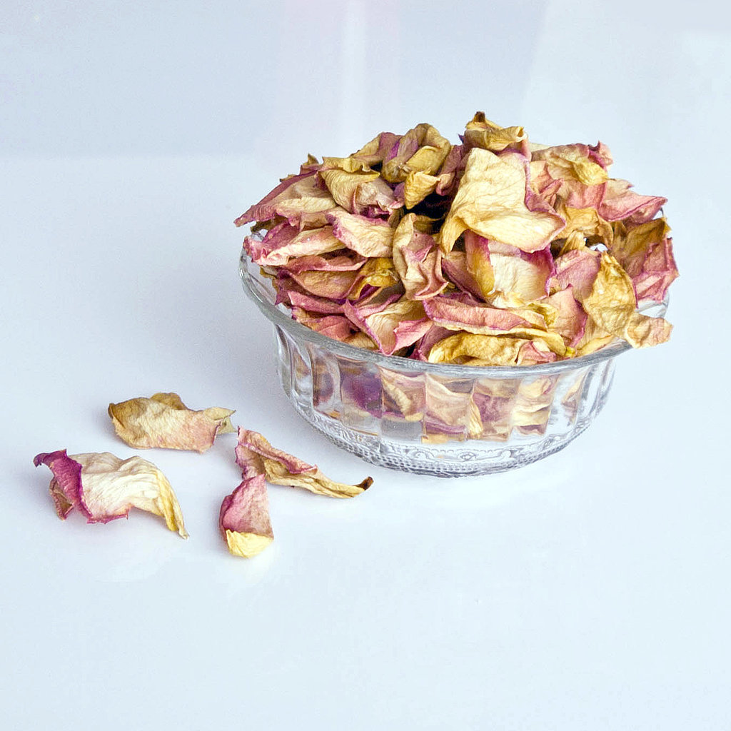
Make This Sweet Homemade
Rose Petal Potpourri

The next time your beautiful bouquet of roses starts to wilt, instead of throwing the pretty petals in the rubbish, make potpourri. Rose petals have a calming scent, and creating a mix that leaves a lovely lingering scent in your home is so easy. This DIY also makes a memorable homemade gift.

What You Need:
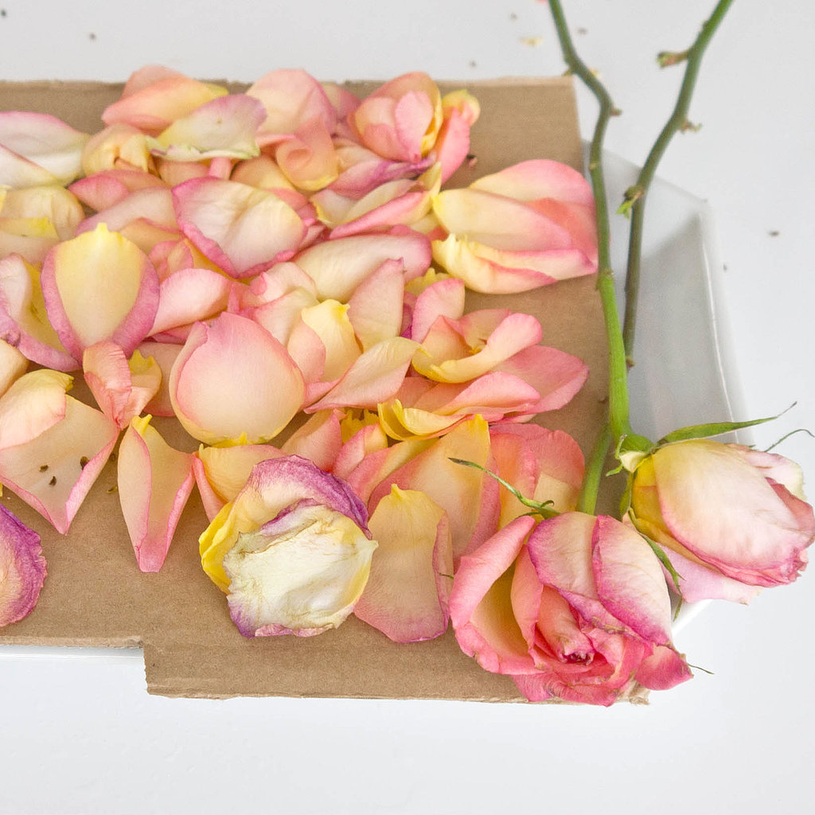
One dozen roses
Large plate
Newspaper or cardboard
1/2 teaspoon ground cinnamon
1/2 teaspoon dried lavender
Rose essential oil or rosewater (optional)
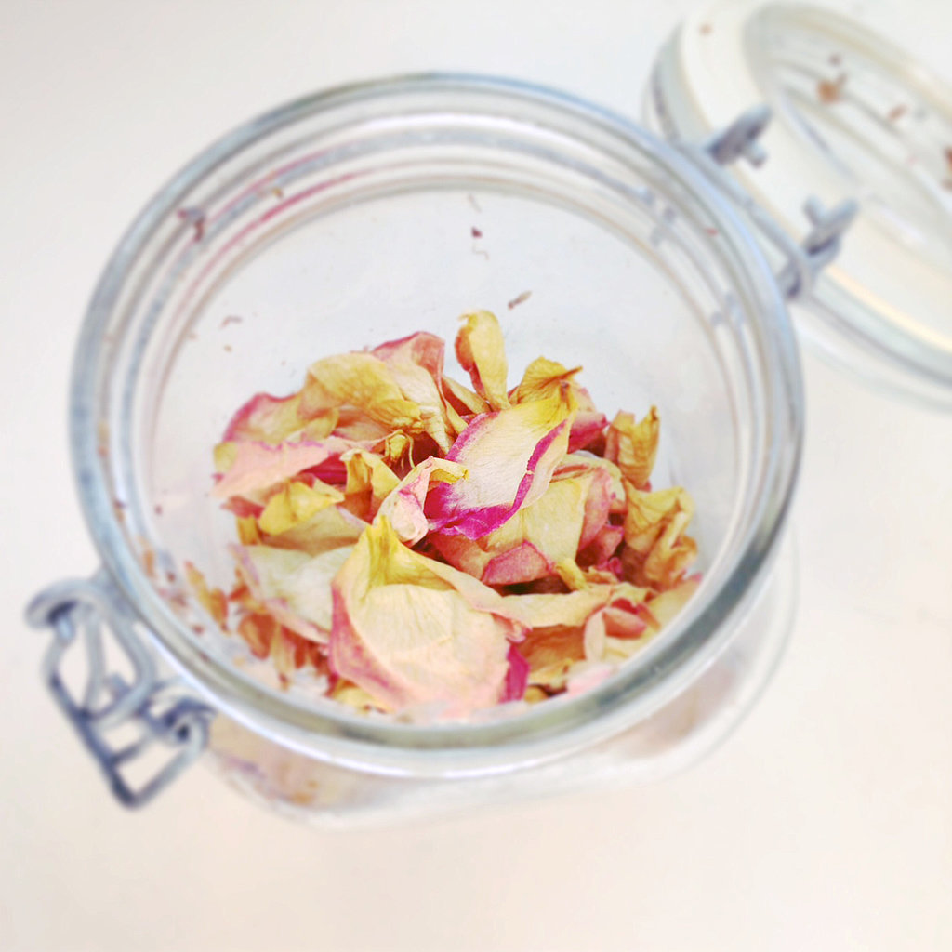
Sealable glass container
Fixative – ground spice or orris root powder to make the fragrance last*
*If you use fragrance oils instead of essential oils, the fixative can be left out.
What you do:
Start by removing the petals from the flowers. Spread the petals over a plate covered with a layer or newspaper or a length of cardboard, which helps dry the flowers. Place them in a warm, dry spot for two to three days.

Once the petals have started to crisp around the edges, place in a sealable glass jar. To set the scent of the flowers, add a fixative, which locks in the wonderful aroma. Sprinkle the mixture with one half teaspoon each of ground cinnamon and ground lavender. Take the potpourri to the next level by sprinkling it with four to five drops of rose essential oil or rosewater. Close the container, and shake. Leave in a warm, dry spot for 24 hours, and then shake again.

Open the jar, and enjoy your homemade potpourri! If you want a stronger scent, then sprinkle it with an additional one quarter teaspoon each of ground cinnamon and dried lavender and a few extra drops of rose essential oil. Close the lid, and shake, letting the potpourri rest for 24 hours or up to one week, shaking the jar every couple of days.

Check out our Pinterest board for other Sensory Ideas

