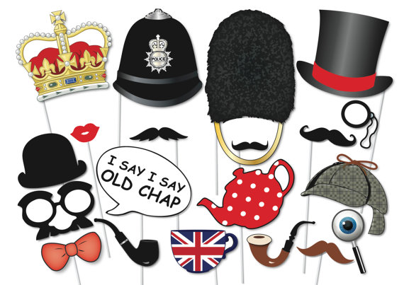
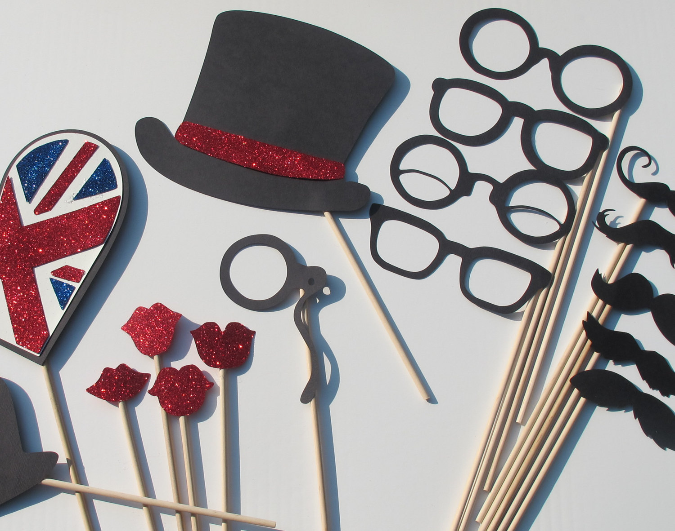
Photo Booth Props
For your Right Royal Street Party!

What you need:
Templates / someone who can draw
Card
Kebab skewers
Materials to decorate – paint, glitter

Get creating!
Use the images to give you ideas!

I had added a PDF- download and print it for lots of props!

Follow this link to download 10 FREE printable photo booth props http://www.bespoke-bride.com/2012/12/11/10-free-photo-booth-prop-printables/

