Poinsettia Serviette Ring

Materials for 60+
2.5 yards red felt
1 yard green felt

Tools
Scissors

Method
Cut one red flower (the larger template); and one each red and green of the leaves (the smaller template).

Nip a hole in one end of the flower and in the centre of both leaves, by folding in half and snipping with the scissors. If you make the hole too small, you can always make it bigger, but if you make it too big, you have a problem. The hole in the flower should be smaller than the holes in the leaves.

With the right side of the fabric on the outside bring the petals round towards each other, and push the petals (of the end without the hole) through the hole in the other end.

Place the red leaf on top of the green leaf, right side of the fabric uppermost. Gather the petals together to be as thin as possible, and push them through the holes in the leaves.

Offset the red and green leaves and the petals so that they all show.

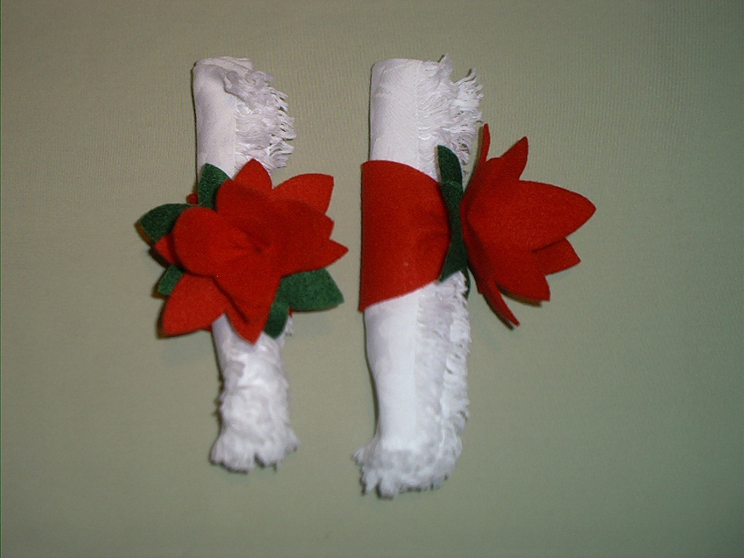


In case the template has become distorted, the large flower template is 11.25” (28.5cm) long, and 3.25” (8.0cm) wide at the fattest point in the centre.

