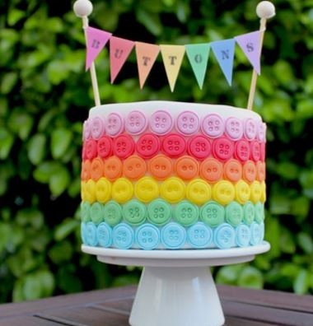
Rainbow Button Cake Decorations

Sourced from www.goodtoknow.co.uk
If you're looking for an impressive way to decorate a small cake then this is it. These pretty rainbow coloured buttons are so simple to make using fondant and modelling paste and will transform your cake into a work of art.
You can pop them on top of individual cupcakes or decorate a whole cake just like our cupcake queen Victoria Threader has done.
You can experiment with different coloured buttons - try pastel colours like baby blue or pink.
What you need:
120g ready to roll fondant
120g modelling paste
Rainbow food colour pastes
1tsp royal icing sugar
10mm & 13mm circle plunger cutter
Writing piping nozzle
Soft brush for gluing

For the bunting:
Printed bunting sheet
Scissors
Alphabet stamps
Ink pad
Bunting pins and twine
Glue stick

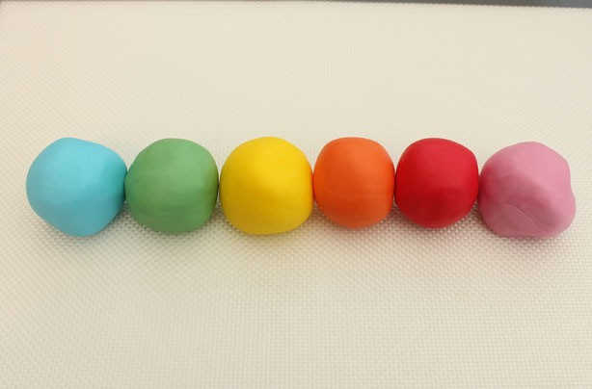
What you do:
Prepare your cake by covering it with fondant.
Knead the modelling paste and fondant together. Using modelling paste in the mix helps the buttons dry faster so they are easier to handle. Colour 6 x 40g in rainbow colours.

When rolling the paste, make sure you cover the other colours in cling film to stop them drying out.
To cut the buttons you will need a 13mm cutter, 10mm cutter and a writing piping nozzle.
Roll the paste out to 2mm thick and cut 24 x 13mm circles.
Using the 10mm cutter, emboss the buttons by pushing the cutter gently into the middle of each circle; don’t press too hard as you don’t want to go all the way through.
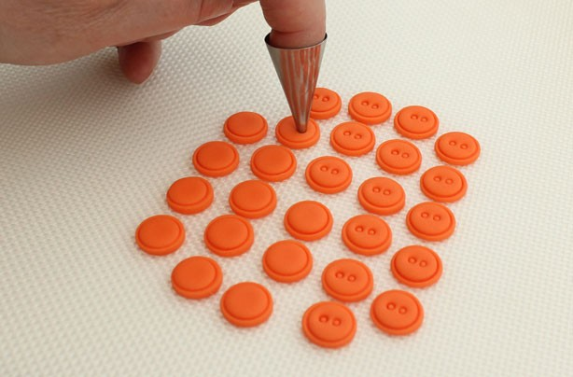

To create the button holes use a writing nozzle. It works quicker to pop the nozzle on the end of your finger and press the tip into the middles of the buttons, not too hard though as you don’t want to go all the way though. You could do some with 4 holes and some with 2.
Once you have embossed the buttons leave them to dry for 10 minutes, this will make them easier to handle and it makes sticking much faster too. Just use a palette knife to pick them up.
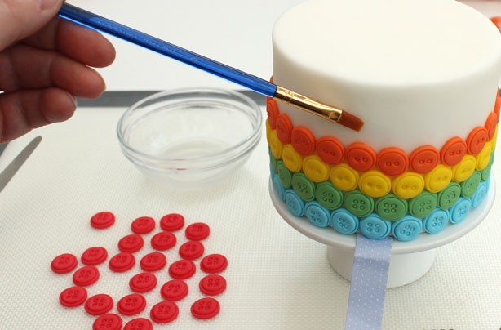

Mix the icing sugar with a few drops of water to make edible glue and wiping the excess off the brush, paint the edible glue onto the cake, sticking the buttons as you go.
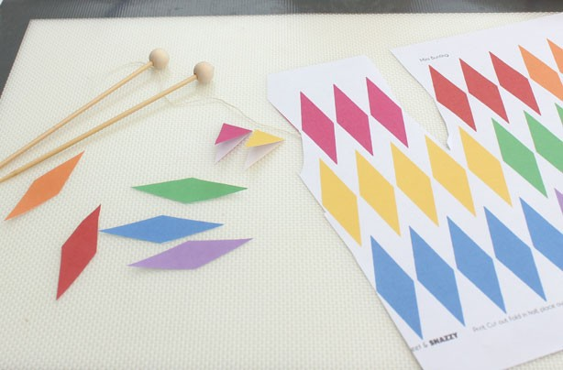

To make the bunting, print the bunting shapes from your computer and cut out. Bend the bunting over the twine and stick down with a glue stick, and then tie to the bunting pins.
Complete the bunting by embossing the word “Buttons” onto the bunting using the embossing sticks and an ink pad.
Push the bunting into the cake and serve.

