SNOW GLOBE CUPCAKES WITH GELATINE BUBBLES
Idea sourced from www.sugarhero.com/snow-globe-cupcakes-gelatin-bubbles/

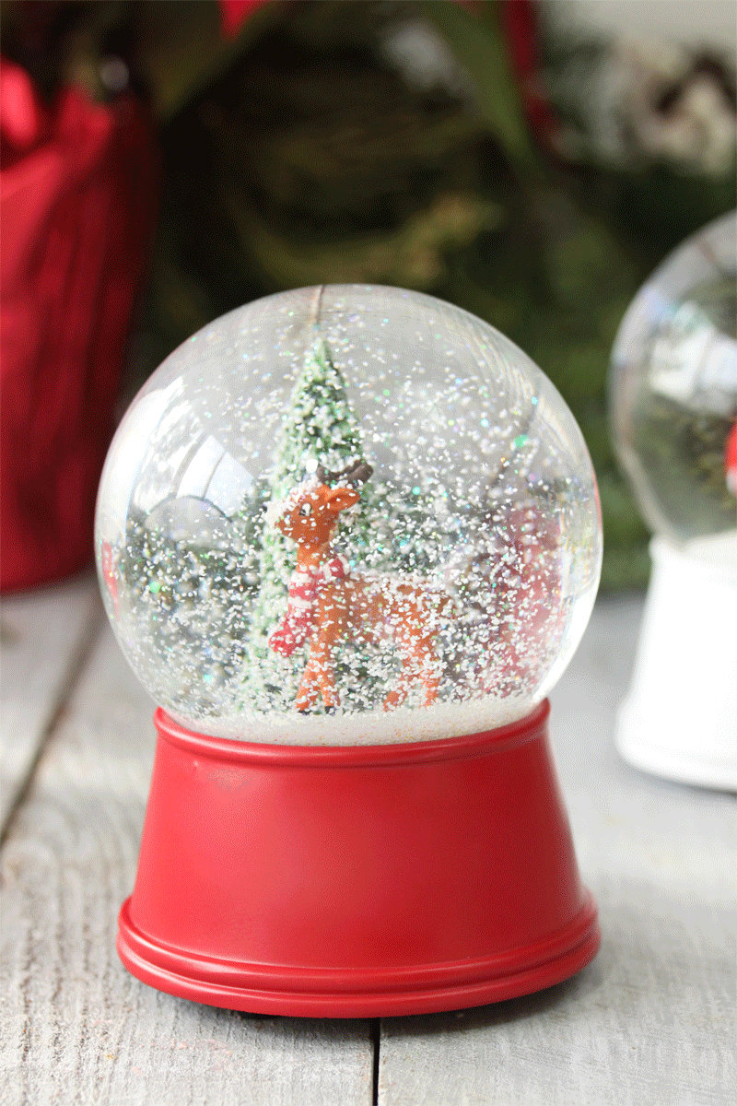
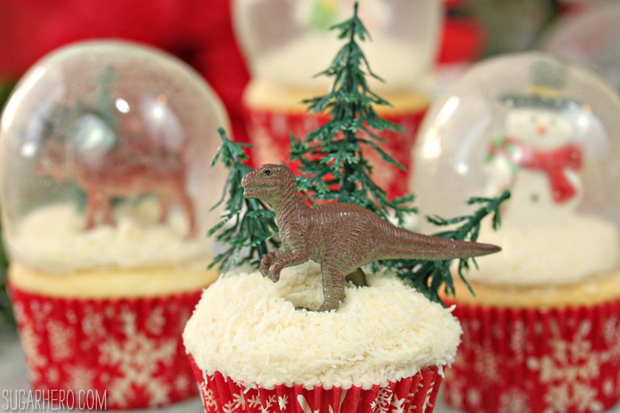
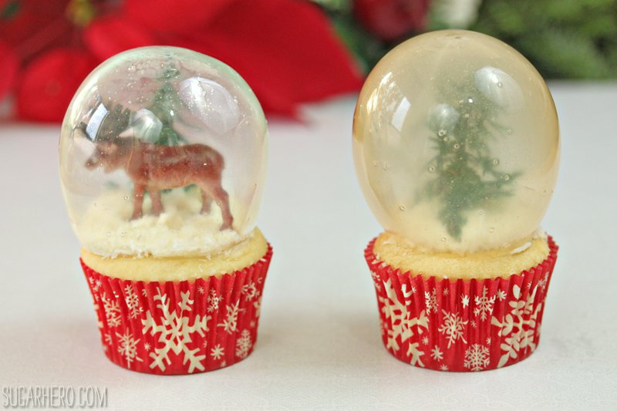

I used regular vanilla cupcakes and topped them with a thin layer of vanilla butter cream, and then I rolled the tops in shredded coconut. If you’re using standard water balloons like I was, you’ll probably want to make sure to leave a margin along the edges of the cupcake, because the gelatine balloon will be a little smaller than the cake and you want to keep the coconut “snow” inside the balloon’s walls.
To fill the snow globes, I used some trinkets I found at the local craft shop and cake supply shop: cute little snowmen, reindeer, evergreen trees…and maybe a dinosaur or two I stole from my son’s collection. How funny would it be to serve your guests snow globe dinosaur cupcakes? We wish you merry rex-mas…

I first read about gelatine bubbles when I pinned this gorgeous pearl cake from Cake Central, and I first saw them on cupcakes when Heather made these Bubble Gum Frosting Cupcakes. The actual method isn’t too hard, and if you prepare them like those tutorials suggest, you probably have the ingredients (powdered gelatine and water) in your house already.

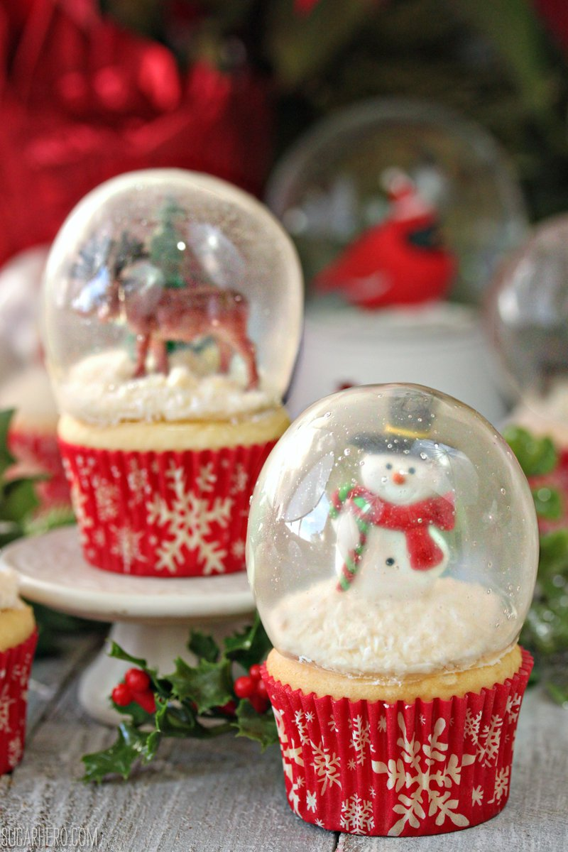
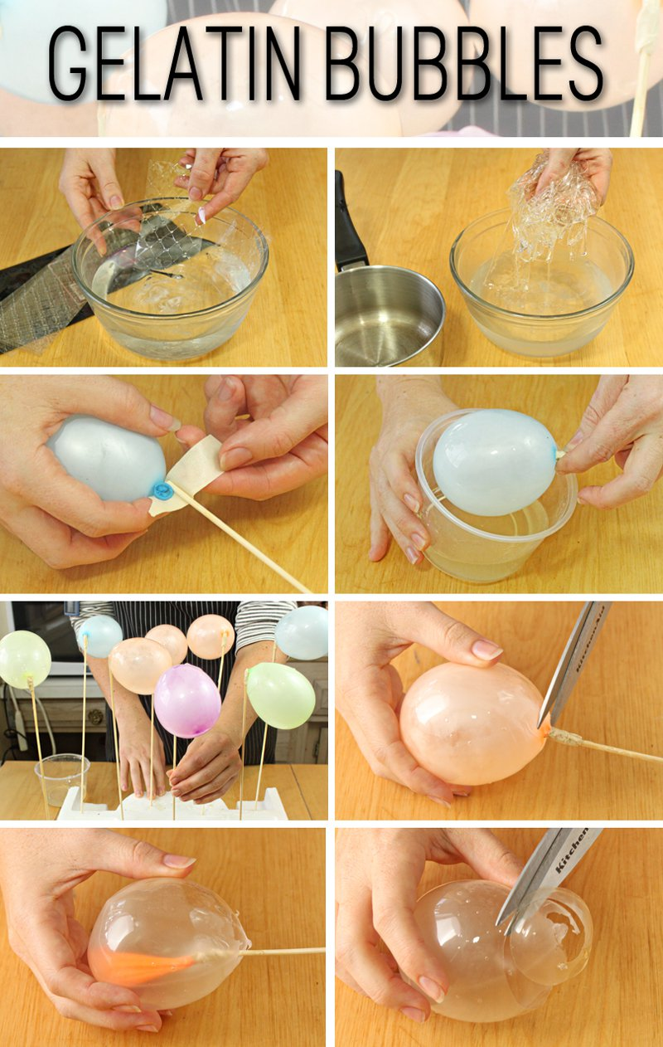
Eventually, my experiments led me to these platinum gelatine sheets. Gelatine sheets, also known as leaf gelatine or gelatines, are what I’ve always used in professional kitchens. Although I believe they’re much more common in other parts of the world, in the US they’re rarely found in regular grocery shops, and instead, we have easy access to powdered gelatine, like Knox brand. The powdered gelatine works well for most applications, but if given a choice, I’d choose gelatine sheets every time. They’re easy to work with, and they have a cleaner texture, clearer colour, and less of a strong “gelatine” taste. There is much more to be said about the differences between types of gelatine, but why would I go on about it when David Lebovitz has already written a great post all about gelatinee? Gelatine sheets come in different strengths (bronze, silver, gold, and platinum), and I chose the highest grade, platinum, because it is the strongest, purest, and clearest available. (If you only have access to a different grade of gelatine sheets, you can absolutely make these gelatine balloons work, but you might have to adjust the gelatine/water ratio to get the perfect texture.) All of my trials and experiments were worth it, however, when I finally nailed my method and recipe. The gelatine balloons made with platinum gelatine sheets were strong and beautifully, gloriously clear. They are very difficult to photograph because of the glare, but you’ll have to believe me that they look amazing in person.

Here’s a quick and dirty photo tutorial showing how it’s done! Bloom the gelatine, dissolve it with a bit of water, attach water balloons to skewers, then dunk the balloons. I liked the look of a single dunk the best—just one coating of gelatine produced balloons that were crystal-clear– but the gelatine balloons weren’t quite strong enough when they were coated with just one layer. The single-dipped balloons would crinkle as they were being released, and although they could be popped back into shape, the crinkling left wrinkles in the balloons that made them look less than perfect. I settled for dipping my balloons twice, which produced gelatine bubbles that were mostly clear, but were a bit less transparent and had more surface bubbles as well.
One step that’s not show in the tutorial is the very important step of greasing the balloons ever so slightly. This is a science second only to safe-cracking in its difficulty and reliance on detail! Too much grease and the gelatine won’t stick to the balloon, but omit it and you’ll have a tough time removing the balloon at all. The method that worked the best for me was to spray my hands with non-stick cooking spray, rub them together to get it to absorb, then to rub my hands on the balloons to transfer some of the oil. Just the lightest coating possible is all you need for happy balloons that release easily and cleanly.

The other thing to know about these gelatine balloons is that they take a long time to set—I gave each of my batches a solid 24 hours at room temperature to harden. Yours might be done before this time, and the process is faster if you keep them in front of a fan the whole time, but to be safe, leave yourself at least a day to assemble them.
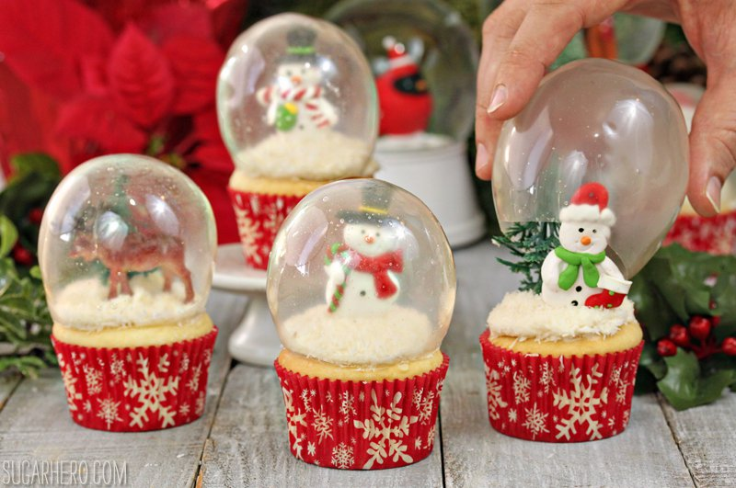
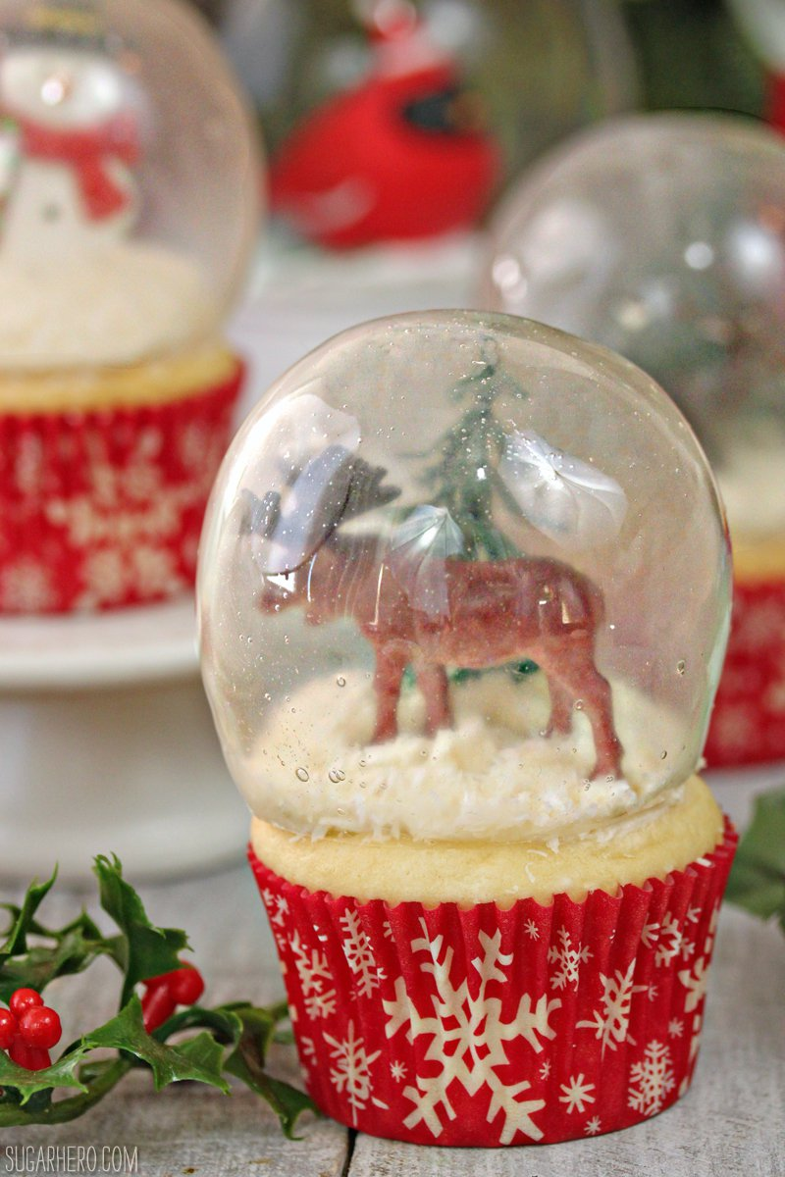

HOW TO MAKE GELATINEE BUBBLES
What you need:

12 sheets of Dr.Oetker Leaf Gelatine 13G
Ice water
8 water balloons
Wooden skewers, tape, and polystyrene
Non-stick cooking spray
What you do:

Fill a bowl with ice water. Add the gelatine sheets one at a time, making sure that they are separated and not in a big clump, and submerge them in the cold water. Let them sit and soften for 10 minutes.
Once they are soft, remove the sheets from the water and gently squeeze out all the excess water back into the bowl. Place the wrung-out gelatine sheets and 3 tbsp of water from the bowl into a small saucepan.
Heat the gelatine over LOW heat, swirling the pan occasionally, until the gelatine is melted. You are not trying to get it hot, so watch it carefully and remove the pan once the gelatine is mostly melted! If it is warm, let it cool until it is no longer warm to the touch, but is still fluid. If it starts to set at any time during this process, return it to low heat briefly just until it becomes liquid again.
Blow up 8 water balloons to your desired size and tie them tightly. Securely tape them to long wooden skewers. Spray non-stick cooking spray on your hands, and rub your hands together until most of the oil is absorbed. Gently rub your hands on the balloons, transferring just a little oil to them—they should not be shiny or greasy at all, or the gelatine won't stick. You should be able to do several balloons before spraying your hands again.
Transfer the gelatine to a small cup or bowl, narrow enough so that it will be fairly deep when you dip the balloons. Dip one in the gelatine entirely, turning it until it is nearly covered—it's okay to leave the part near the knot/skewer uncovered. Let the excess gelatine drip back into the bowl, and once it has stopped dripping, stick the skewer in the Polystyrene board. Repeat until all of the balloons have an initial gelatine layer.
Let the balloons set for about 10 minutes, until they are no longer tacky to the touch. If necessary, re-warm the gelatine just until it is fluid, but do not make it warm again—if it feels warm, let it cool to room temperature. Re-dip the balloons a second time, and then place them back on the Polystyrene board. Let the gelatine balloons sit at room temperature for about 24 hours. If you want to speed up the process, you can place them in front of a low fan, which might cut your time in half or even a quarter.
The balloons are done when they feel hard, like plastic or egg shells, when you tap them with a fingernail. They should not feel soft at all. To release them, cut a hole in the balloon near the stem. Ideally, the balloon will shrivel up and release easily, pulling itself away from the sides of the gelatine. If it doesn't pull away right away, don't fret and don't pull on it yourself. Set the balloon aside and work on the others. The balloon will naturally shrink on its own and gradually pull away from the sides. It might take 5 minutes or it might take 45, but eventually the balloon will pull away from the gelatine.
Gelatines balloons can be stored indefinitely in an airtight container at room temperature.
Notes
To use powdered gelatine, combine 1 part unflavoured powdered gelatine with 2 parts cold water. (1/4 cup gelatine and ½ cup water will yield about 8 balloons.) Whisk the gelatine and water together, and then let it sit and soften the gelatine. Once the gelatine has absorbed the water, gently heat it up in the microwave in short intervals. Try to swirl the gelatine rather than stirring it, since stirring can lead to a lot of air bubbles. Once it's entirely melted, let it cool to barely warm before dipping the balloons as described above. Reheat the gelatine as necessary to get a dippable consistency.

SNOW GLOBE CUPCAKES WITH GELATINEEE BUBBLES

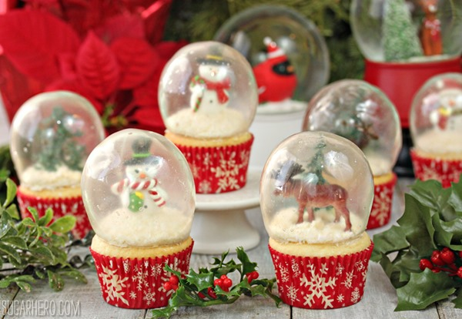
Print
Author: Elizabeth LaBau
Serves: 8
Ingredients
- 8 cupcakes, baked and cooled
- 1 cup frosting of your choice
- Flaked coconut
- Snow globe-appropriate cupcake toppers like snowmen, Santa’s, reindeer, trees, etc
- 8 gelatine bubbles
Instructions
- Transfer the frosting to a piping bag fitted with a round tip, or a plastic bag with a hole cut in the corner. Pipe a thin ring of frosting on top of the cupcakes, leaving a margin around the edges so that the gelatine bubble can enclose the frosting entirely.
- Roll the top of the cupcakes in the flaked coconut. Add a cupcake topper or two to each cupcake—if it helps, you can glue a toothpick onto the back and use that the secure the toppers to the cupcakes.
- Trim off the bottom of the gelatine bubbles, making a hole big enough to fit on top of the cupcake around the frosting. Carefully place a bubble on top of each cupcake. The bubbles will last indefinitely, but if they're exposed to a lot of moisture in the refrigerator or the frosting, they might eventually start to soften and lose their shape.

