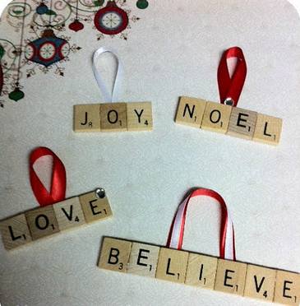
Scrabble Letters

What you need:
Scrabble letters
Ribbon
Glue
Backing card
Stapler
What you do:
Put the letters together to make your chosen words
Glue onto backing card
Glue or staple the ribbon onto the back

Think box: you could make these for so many different occasions:
Place settings for meals
Names on people’s doors
Key rings

