Sequin Angels

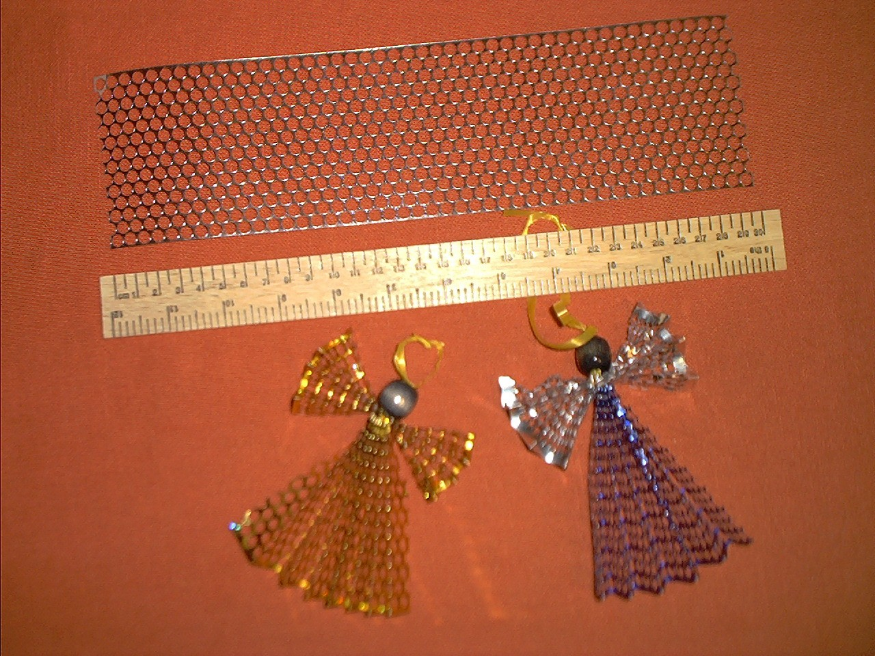

Tools: ruler or tape measure and scissors for leader
You will need: 30cm (12") sequin waste, 15cm (6") sequin waste, 20cm (8") thin (0.4cm or 1/8") piece plastic ribbon, and one large bead (those car seats covers were ideal for this, and I've got loads left)
Method: Take the longer piece of sequin waste, and fold as a concertina, with folds of about 2cm (just under 1"), this is for the dress. Thread the plastic ribbon through the folds in the middle of one side, have the same length hanging out both ends, pull tight, and tie a knot. The dress should fan out.
Take the shorter piece of sequin waste, and fold with folds of a similar width. Thread the ribbon through the middle hole in the sequin waste (if there are an even number of holes across, then you can thread it through the two central holes, and tie off), on the last fold, make sure you go through different holes so that you can pull the thread tight and tie a knot. These form the arms of the medieval dress (or angel's wings).
Slip the bead on for the head, and tie a knot - this will probably slip down inside the bead, but it doesn't matter, as it will provide friction to help to keep the bead on. The ends can be tied in a knot so that Guinevere may be hung on the Christmas Tree ;-)
If you want a real Guinevere, you can put a hat made from a triangle of pretty paper on her head, with the ribbons trailing through the pointed end.

