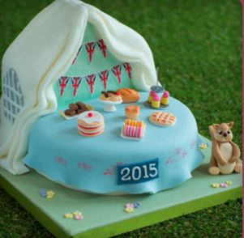
Tea Party Cake
Recipe found on bakingmad.com
What you need:
For the 8” cake
225g unrefined golden caster sugar
225g self-raising flour
1tsp vanilla extract
225g unsalted butter
2tsp baking powder
4 eggs
For the loaf cake:
175g unsalted butter
3 eggs
200g self-raising flour
175g unrefined golden caster sugar
2tsp vanilla extract
50g ground almonds
For the buttercream:
600g unrefined golden caster sugar
300g unsalted butter
1tsp vanilla extract
For the decoration:
2 ½ kg white sugar paste icing
1kg flower paste icing
Food colouring, green, blue, yellow, pink, red, brown and grey.

What you do:

For the 8/2 cake, preheat the oven to 180c (160c gas mark 4) and grease and line 2 8” sandwich tines.
Beat together all the ingredients until light and fluffy. Divide the mixture evenly between the 2 tins. Bake the cake for 25 minutes until golden and baked throughout. Leave on a wire rack to cool.
For the loaf cake, grease and line a loaf tin and preheat the oven to 170c (150c gas mark 3).
Beat together the sugar and the butter until light and fluffy. Then add the vanilla extract and the eggs one by one, beating with each addition. Beat in the flour and almonds until you reach a thick batter consistency. Then pour into the loaf tin and bake for 55minutes – 1 hours until baked throughout. Leave to cool on a wire rack.
Whilst the cakes are cooling make the buttercream by blending together the butter, icing sugar and vanilla extract until smooth. Sandwich together the 8” cakes and cover with buttercream and white sugar paste icing. Slice off a 1/3 of the cake at the back.
Knead together 50% sugar paste and colour light blue, to create the table cloth. Brush the top of the white icing and layer with the blue sugar paste, trimming off and access and shaping to give a ruffled effect.
Position the loaf tin cake horizontally behind the circular cake and cover in buttercream. Place the cut off piece of sponge cake on top and using a knife carve a triangular shape to form the roof of the tent. Cover these cakes with green coloured sugar paste icing.
Roll out green sugar paste icing and cover a square cake board. Place the cakes in the centre of the board.
Roll our long strips of white sugar paste icing and kneaded with flower paste icing and drape over the tent cake securing in place with water. Use grey sugar paste icing to create the window effect.
Colour the remaining icing to create the decorations and for an added finishing touch why not make your own bunting to decorate the cake.

