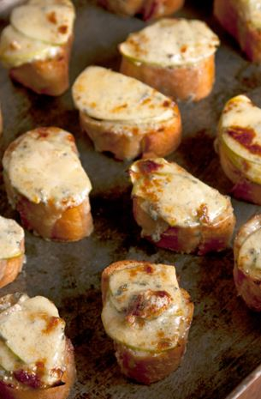
Apple and Stilton
Welsh Rarebit Bites

MAKES 24 BITES
Ingredients
¹⁄₂ thin baguette, cut into ¹⁄₂" slices
3 tbsp. unsalted butter, melted
1 small tart apple, such as Granny Smith, peeled, halved, cored, and thinly sliced
8 oz. crumbled stilton or blue cheese, at room temperature
3 tbsp. crème fraîche
1 tsp. Worcestershire sauce
1 tsp. dijon mustard
1 tsp. honey
Kosher salt and freshly ground black pepper, to taste
Instructions
Heat a grill pan over medium-high heat. Brush baguette slices with melted butter; working in batches, grill, flipping once, until golden on both sides, about 2 minutes. Transfer to a parchment paper-lined baking sheet. Layer 2 apple slices on each toast; set aside.
Mix cheese, creme fraiche, Worcestershire, dijon, honey, salt and pepper in a small bowl. Spread about 1 tbsp. of the cheese mixture over each toast. Grill on a medium heat until topping is melted and golden brown, about 4 minutes.

