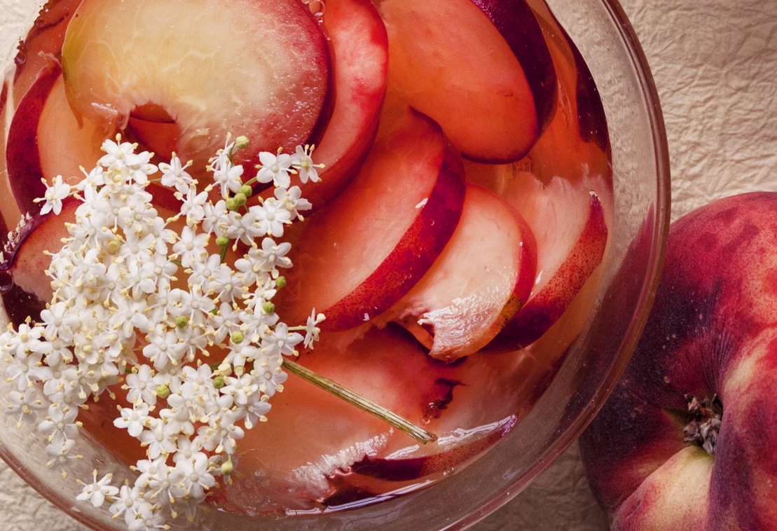
White peach and elderflower jellies
Makes 4
For the peaches:
white peaches 125g
lemon juice of ½
For the jelly:
leaf gelatine 10g (6 small sheets)
elderflower cordial 100ml
white wine 350ml
caster sugar 1 tbsp (optional)
Half-fill a mixing bowl with cold water then add the sheets of gelatine. If you do this one at a time, it will prevent them from sticking together. Leave the gelatine to soften for 10 minutes, in which time it becomes a clear, spongy mass.
Pour the elderflower cordial and white wine into a medium-sized saucepan, add the sugar (or not, if you prefer a sharper jelly) and warm over a moderate heat. Don’t let the mixture boil, which would affect the gelatine’s setting qualities.
Cut the peaches in half then into thin slices, discarding the stone as you go, then toss them gently in the lemon juice to prevent them from browning. Divide the peaches among four small serving dishes.
Lower the softened gelatine into the warmed cordial and wine, then stir until it has dissolved. It should disappear almost instantly. Pour into a jug then into the dishes to cover the peaches, then refrigerate for about four hours, until lightly set.
Recipe sourced from http://www.theguardian.com/lifeandstyle/2015/jul/12/nigel-slater-jelly-recipes

