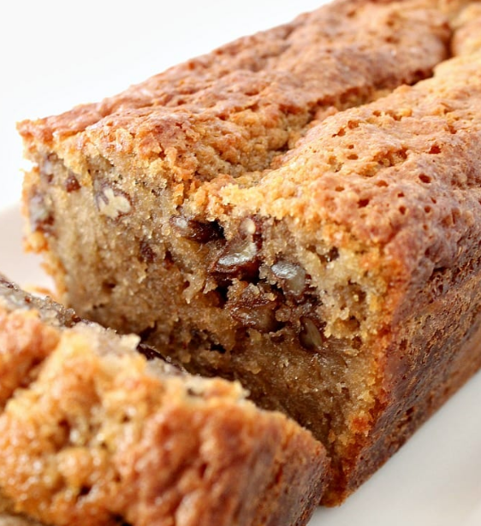
Coffee Pecan Pound Cake

Coffee Pecan Pound Cake is a lovely tasting, moist cake with a perfect combination of coffee flavour and texture from the pecans. Delicious with a cup of coffee!

Ingredients
- 175 g softened butter
- 175 ml milk
- 290 g granulated sugar
- 3 eggs lightly beaten
- 4 Teaspoons of coffee granules dissolved in 2 Tablespoons hot water.
- 225 g Plain / All purpose flour sieved
- 1 1/2 tsp baking powder
- 1/2 tsp salt
- 140 g Pecans
Instructions
- Heat oven to 160 C, Gas 3, Grease and line your baking tin. See here for how to line.
- Get all your ingredients ready, i.e dissolve the coffee, sieve the flour, and add the salt and baking powder to the flour etc. Crush the pecans a little with your hand so they are not such big pieces.
- Start with making the cake batter by creaming the butter and sugar until a pale light colour.
- Slowly add the beaten eggs to the mixer, on a low speed setting, a bit at a time. If the mixture starts to curdle or split, add a spoonful of your sieved flour, keep on adding the eggs, and a bit of flour if necessary, until all the eggs are added.
- Add half the milk with half of the flour, keeping the mixer on a slow speed. Once combined, add the coffee mixture, the rest of the milk and flour. Fold in the pecans.
- Transfer the cake mixture to the greased and lined loaf tin. Drop it from a 3 cm height onto the work surface to level it out, then place in the oven for 1hr and 20 minutes, check after 1 hour and 5 minutes to see if it is cooked, using a skewer. Every oven varies, so keep an eye on your cake!
- Have a cup of tea!
- Allow to cool. Store in an airtight container. You can also freeze half or all of it, wrap in parchment paper, then place in a zippy bag. Defrost as normal and enjoy! It will still be moist.

