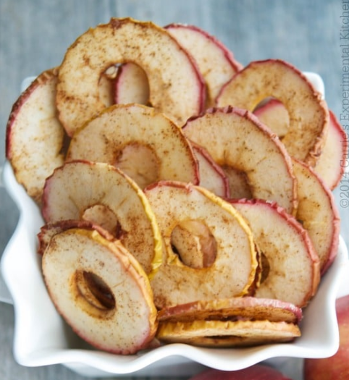

Cinnamon Apple Chips

What you need
- 4 Apples, cored and sliced 1/8” thick
- 1-2 tsp . Ground Cinnamon
- 1-2 tsp . Granulated Sugar, if needed
- Cooking Spray
What you do
- Preheat oven to 140c / gas mark 3
- Add the sliced apples to a large bowl; then coat the apples with the cinnamon and/or sugar.
- Spray a baking sheet with cooking spray and line the apples flat on the pan. You may need to use two pans so that they are not overlapping.
- Bake 2-3 hours until the chips are dry yet still soft. Allow to cool completely before placing them in an air tight container for up to 4 days (if they last that long!).

