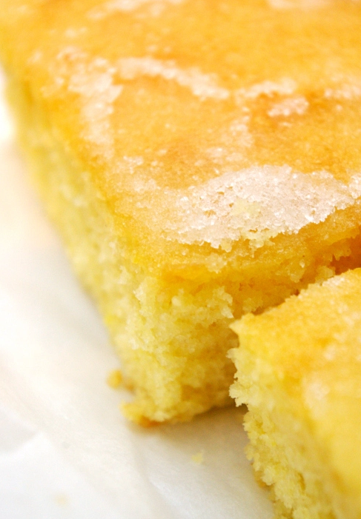
Lemon Drizzle Tray Bake

What you need:

Self raising flour 275g
Butter, softened 225g
Caster sugar 225g
Caking powder 2tsp
Milk 4tbsp
4 large eggs
Grated zest of 2 lemons

For the topping:
Juice of 2 lemons
granulated sugar 175g

What you do:
- Lightly grease and line a 30 x 23cm tin. Preheat your oven to 160°C.
- If you have an electric mixer, mix all the ingredients together in a large bowl. If, like me, you don’t have an electric mixer, start by creaming the butter and sugar together, add the eggs and milk and mix well, then add the flour, baking powder and lemon zest and continue to mix well for a few minutes.
- Empty the mix into the tin and level the top with the back of a wooden spoon or spatula.
- Bake for approximately 40 minutes, until golden and the sponge springs back when pressed lightly.
- Leave the cake to cool in the tin for a few minutes. Carefully remove the paper and allow the cake to cool on a wire rack.) Prick the cake all over the top with a fork. This will allow the topping to sink into the cake a little way and imbue it with lovely lemony sugary mmmmm-ness!
- While the cake is cooling, mix the topping ingredients together in a small bowl. Drizzle the topping over the cake while it’s still slightly warm. When the cake cools, this ‘syrup’ forms a crunchy lemony sugary glaze.
- Cut into squares once completely cooled. Grab some for yourself before it all disappears!

