Australian Folk Songs
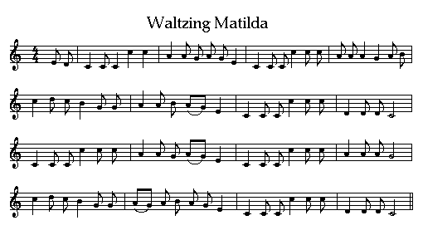
Waltzing Matilda
Oh there once was a swagman camped in a billabong
Under the shade of a coolibah tree
And he sang as he looked at his old billy boiling
Who'll come a waltzing Matilda with me
Chorus
Who'll come a waltzing Matilda my darling
Who'll come a waltzing Matilda with me
Waltzing Matilda and leading a water bag
Who'll come a waltzing Matilda with me
Down came a jumbuck to drink at the water hole
Up jumped the swagman and grabbed him with glee
And he sang as he stowed him away in his tucker bag
You'll come a waltzing Matilda with me
Down came the squatter a riding on his thoroughbred
Down came the troopers one two three
Whose is that jumbuck you've got in the tucker bag
You'll come a waltzing Matilda with me
But the swagman he up and he jumped into the water hole
Drowning himself by the coolibah tree
And his ghost may be heard as it sings in the billabong
Who'll come a waltzing Matilda with me

