Cheesy Baked Plantains with Chilli - West African Flavours
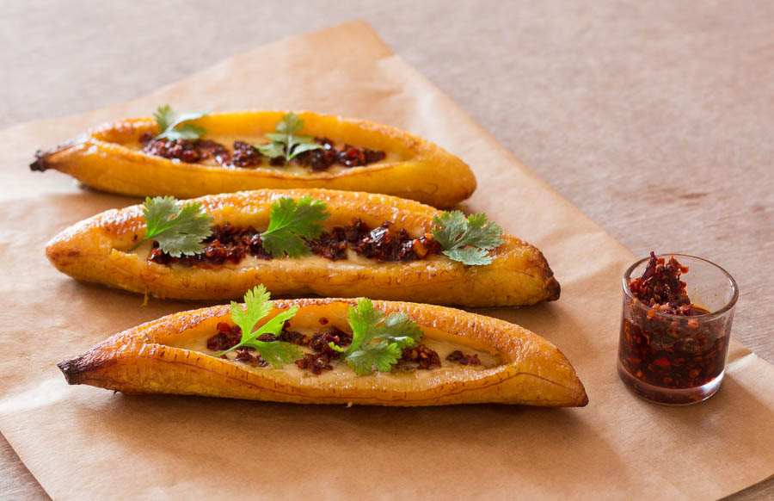
Easy baked ripe plantain stuffed with cheese and chilli

What you need:

- 3 ripe plantains peeled
- Oil to brush plantains
- 85 g / 3oz finely grated Barber's 1833 vintage reserve Cheddar
- 1 tsp crunchy chilli sauce

What you do

- Preheat oven to fan assisted 180C /375F / gas 5.
- Make a lengthways slit along the plantains leaving at least 5cm at each end so they stay whole during baking.
- Brush the plantains with some oil, place them on a lightly oiled, lined baking tray and bake for 40 mins making sure to turn them half way through.
- Remove plantains from the oven, place them slit side up and stuff them with the cheddar cheese.
- Return stuffed plantain to the oven and bake for about 5 mins or until the cheese is melted.
- Serve plantains warm drizzled with chilli sauce.

