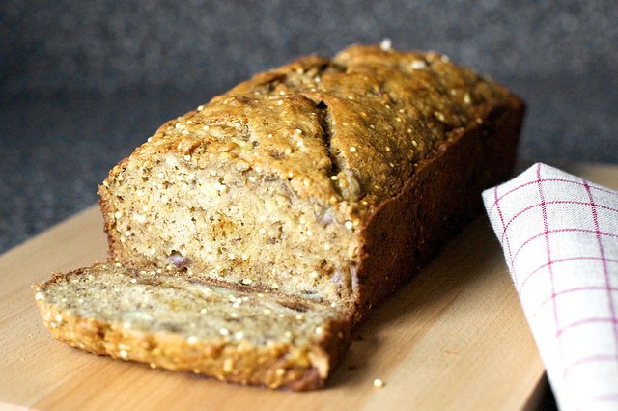
Crackly Banana Bread

What you need:

- 3 large ripe-to-over-ripe bananas
- 1 large egg
- 80 ml virgin coconut oil, warmed until it liquefies, or olive oil
- 65 grams light brown sugar
- 60 to 80 ml maple syrup (less for less sweetness, of course)
- 1 teaspoon (5 ml) vanilla extract
- 1 teaspoon (5 grams) baking soda
- 1/4 teaspoon table salt
- 1 teaspoon ground cinnamon
- 1/4 teaspoon freshly grated nutmeg
- Pinch of ground cloves
- Salt
- 180 grams white whole-wheat flour
- 50 grams uncooked millet

What you do:
- Preheat your oven to 175c / Gas mark 4 and butter a 9×5-inch loaf pan.
- In the bottom of a large bowl, mash bananas with a potato masher or the back of a wooden spoon until virtually smooth but a few tiny lumps remain.
- Whisk in egg, then oil, brown sugar, syrup and vanilla extract.
- Sprinkle baking soda, salt, cinnamon, nutmeg and cloves over mixture and stir until combined.
- Stir in flour until just combined, then millet.
- Pour mixture into prepared pan and bake until a tester comes out clean, about 40 to 50 minutes. Cool loaf in pan on rack.

