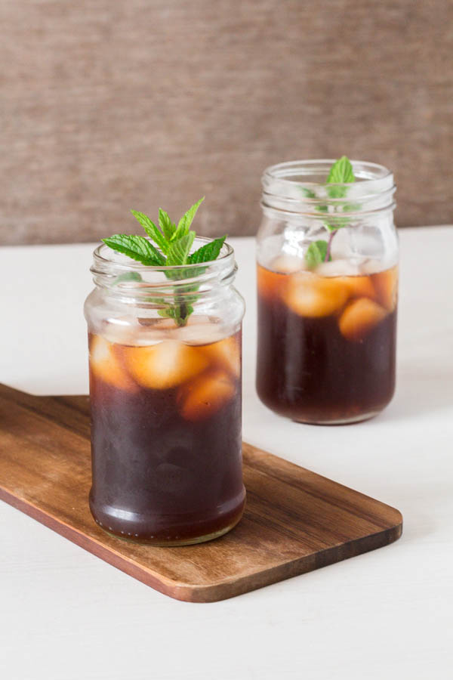
Ginger and Lemongrass Iced Tea - Sierra Leone Flavours
A refreshing ginger and lemongrass iced tea recipe.

What you need:
- 1 large stalk lemongrass outer leaves removed and sliced
- 2-3 tbsp sliced peeled ginger
- 6 rooibos (red bush) tea bags
- 1 litre water
- 3 tbsp honey
- Ice
- Lime slices
- Mint
What you do:

- Put the lemongrass, ginger and water in a pot and bring to the boil.
- Let boil for 1 min and then switch off the heat.
- Add in the tea bags and let steep for 10 mins before discarding the tea bags.
- Stir the honey into the warm tea and set aside to cool before refrigerating for a few hours.
- Strain the mixture and discard the bits, fill the glasses with ice, pour in the tea and garnish with mint.
Recipe Notes
Add more or less lemongrass, ginger and honey to your taste.

