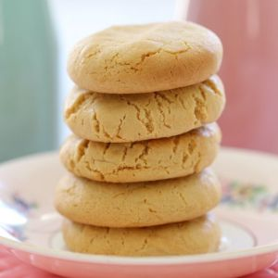
Hokey Pokey Biscuits

What you need:

- 60 g unsalted butter
- 115g golden syrup
- 60g brown sugar
- 225g self-raising flour sifted

- Preheat oven to 180 degrees celsius.
- Line 2 baking trays with baking paper and set aside.
- Melt the butter, golden syrup and brown sugar together in a saucepan over low heat.
- Stir until all of the sugar has dissolved.
- Set aside to cool.
- Sift the self-raising flour on top of the caramel liquid.
- Stir until a soft dough forms.
- Form tablespoon sized balls with the dough and place onto the baking trays.
- Press down lightly with a fork.
- Bake for 10 minutes or until just golden.
- Leave on the baking trays for 5 minutes before transferring to a wire rack to cool completely.
- Store in an airtight container at room temperature for up to 5 days (the cookies will soften over time).

