Iced Rooibos Tea with Raspberries & Mint
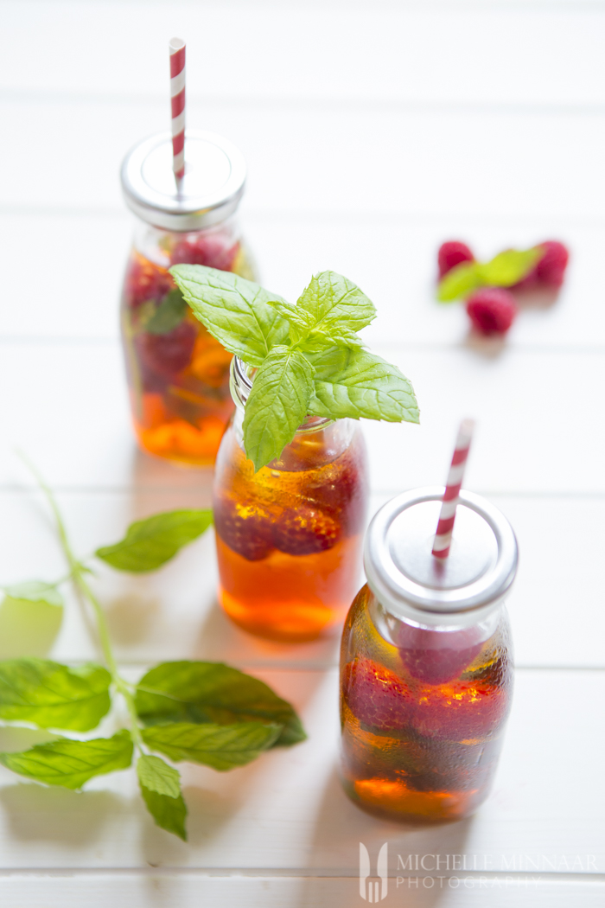
The perfect drink for hot summer days.

What you need:
- 1 litre (2pt) boiling water
- 4 Rooibos ( red bush) tea bags
- honey or sugar to taste
- raspberries
- mint
- ice
What you do:

- Place 4 Rooibos tea bags in a jug.
- Fill with boiling water.
- Allow to brew for 8-10 minutes.
- Remove teabags.
- Add honey or sugar to taste, if desired.
- Add raspberries and mint leaves and leave to cool.
- Serve in a jug with lots of ice.

