Lamingtons
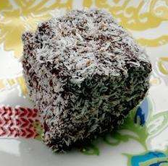

Serves: 24
What you need

Cake
- 125g (4¼ oz) butter
- 150g (5oz) caster sugar
- 1 teaspoon vanilla extract
- 2 eggs
- 250g (9oz) plain flour
- 4 teaspoons baking powder
- 1/8 teaspoon salt
- 120ml (4 fl oz) milk
Icing
- 450g (1lb) icing sugar
- 5 tablespoons cocoa powder
- 1 tablespoon butter, melted
- 120ml (4 fl oz) milk
- 2 (200g) packages desiccated coconut

What you do
Prep:15min › Cook:40min › Ready in:55min
- Preheat oven to 190 degrees C (gas mark 5). Grease and flour a 20x30cm rectangular baking tin.
- Sift together the flour, baking powder and salt. Set aside.
- In a large bowl, cream together the butter, sugar and vanilla until light and fluffy. Add the eggs one at a time, beating well with each addition. Add the flour mixture alternately with the milk; beat well.
- Pour this mixture into the tin. Bake in preheated oven for 30 to 40 minutes, or until a skewer inserted into the centre of the cake comes out clean. Let stand for 5 minutes, then turn out onto a wire rack and cool completely. Store overnight to give the cake a chance to firm up before icing.
- To make the icing: In a large bowl, combine icing sugar and cocoa. In a saucepan, heat milk and 1 tablespoon butter until the butter is melted. Add the milk to the sugar mixture and mix well to create a fluid, but not too runny, icing.
- Procedure: Cut the cake into 24 squares. Place coconut in a shallow container. Using a fork, dip each square into the icing, then roll it in the coconut. Place onto a cooling rack to dry. Continue for each piece. The icing will drip, so place a sheet of greaseproof paper under the rack to catch the drips.

