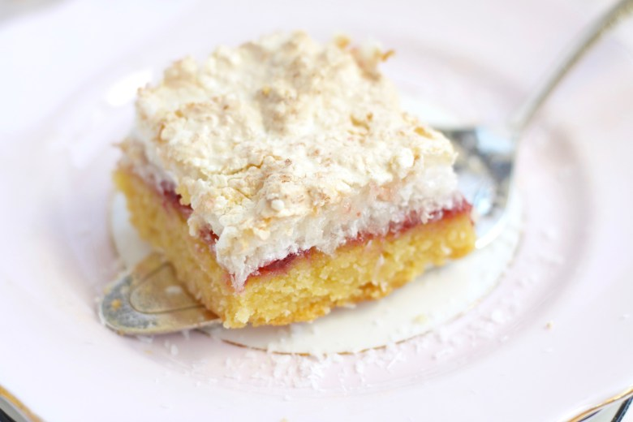
Louise Cake Slice

What you need:
- 190g butter, softened
- 220g caster sugar
- 1 teaspoon vanilla extract
- 3 egg yolks
- 275g Plain flour
- 1 + 1/2 teaspoons baking powder
- 1/4 teaspoon salt
- 1 cup berry jam (I like to use raspberry or strawberry)
- 1/2 cup fresh raspberries (optional)
Topping
- 3 egg whites
- 170g caster sugar
- 110g desiccated coconut
- 1 teaspoon vanilla
What you do:
- 1. Preheat oven to 160C (320F) and line a 20cm x 30 cm (9 x 13 inch) cake pan with baking paper.
- 2. In a large bowl, cream butter and sugar together with a hand or stand mixer until light and fluffy. Add vanilla extract and eggs and continue to beat until combined (be careful not to over-mix).
- 3. In a small bowl sift flour, baking powder and salt together and whisk well to combine. Add this to the butter-sugar mixture and mix until it comes together. Press the mixture into prepared cake pan firmly and bake for 20 minutes or until lightly golden.
- 4. While the base is cooking, make topping: Place egg whites in a clean bowl and beat with a clean beater until soft peaks form. Beat in sugar until mixture forms a glossy meringue. Fold in coconut and vanilla.
- 5. Cool cooked base for 10 minutes, then spread with jam and dot berries over top (if using). Top with coconut meringue topping and bake until crisp and lightly golden (about 35 minutes). Cut into squares whilst still warm.
- Notes
- * When stored in an airtight container, it will keep for up to two weeks. It also freezes well.
- ** If you would prefer a round Louise Cake, bake in a 23cm/9inch round cake tin instead (baking times should be the same).

