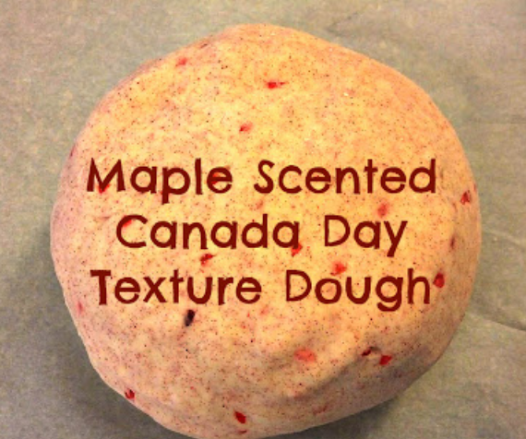
Maple Scented Canada Day Texture Dough

What you need:

2 cups plain flour (all purpose)
2 tablespoons vegetable oil
1/2 cup salt
2 tablespoons cream of tartar
Up to 1.5 cups boiling water (adding in increments until it feels just right)
food colouring (optional)
few drops glycerine (optional- adds more shine!)
1 tablespoon maple syrup
Red glitter or sand
What you do:

Mix the flour, salt, cream of tartar , gliutter / sand and oil in a large mixing bowl
Add food colouring and maple syrup to the boiling water then into the dry ingredients (colour optional)
Stir continuously until it becomes a sticky, combined dough
Add the glycerine (optional)
Allow it to cool down then take it out of the bowl and knead it vigorously for a couple of minutes until all of the stickiness has gone. * This is the most important part of the process, so keep at it until it’s the perfect consistency!*
(If it remains a little sticky then add a touch more flour until just right)

When I think of Canada, I think of maple syrup. So I made a fresh batch of play dough (I only ever use the Imagination Tree's no-cook playdough recipe). However, to make it distinctly Canadian, I added a tablespoon or so of maple syrup to the hot water before mixing it together. You could probably substitute maple extract. I also added an abundance of red glitter and some red glitter gravel that I found at the dollar store. Voila! A wonderful textured play dough with a subtle hint of maple. Mmmm...Pair it with some maple leaf cookie cutters for some extra Canada Day fun.

