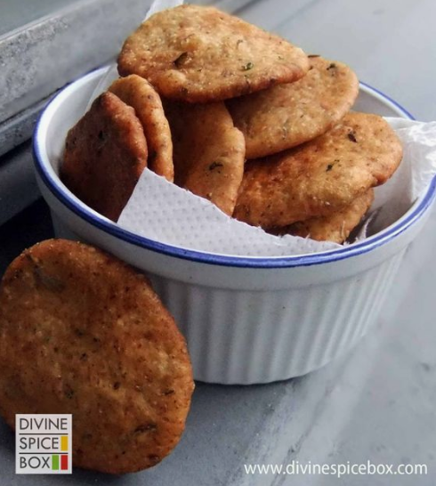
Masala Mathri – India

What you need
2 cups All purpose flour
1/2 cup Oil
salt to taste
5-6 tablespoons of water, room temperature
2 tablespoons of dried fenugreek leaves - Sainsburys
1/2 tsp red chili powder
5-6 peppercorns, crushed
pinch of asafoetida – Sainsburys
1 tsp curry powder
1 tsp garam masala
1 tsp garlic powder (optional)
1 tablespoon onion powder (optional)
Oil for frying

What you do
- Take a bowl and to it, add in the flour and other ingredients except oil, water and oil. Mix well.
- Next, add in the oil and crumble with your hands till the flour starts to resemble bread crumbs.
- Now, slowly add in the water and knead with your hands to make a firm dough. Wrap a plastic film/damp cloth on it and let this dough rest for 10 minutes.
- Now divide the dough into cherry tomato size balls. Take each ball and roll into small, even circle (about 2mm). Take a fork and punch some holes in the dough circles. This would keep the mathris flat while frying and not get puf ed up.
- Repeat this with all the dough balls and keep aside. Meanwhile, heat some oil in a deep pan and heat to medium high.
- Now, add in few Mathris at the same time in the hot oil and let the Mathris cook evenly on both sides. Maintain the medium high heat while frying the Mathris to ensure that they are cooked all the way and get crispy

Source - www.devinespicebox.com

