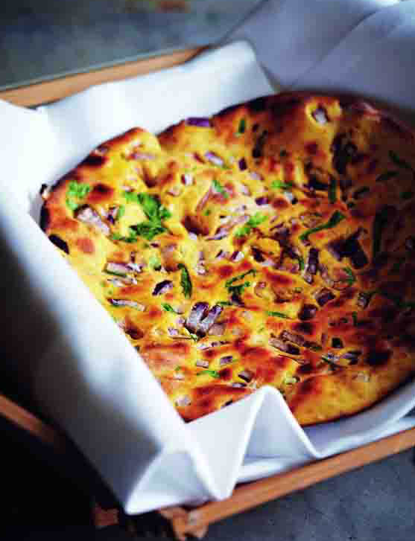
Missi Roti – Sri Lanka

What you need
- 300g chickpea flour
- 200g plain white flour
- 2cm piece of fresh ginger, peeled and finely chopped
- 2 green chillies, finely chopped
- 1 red onion, finely chopped
- 1 spring onion, finely chopped
- 1tbsp finely chopped fresh coriander leaves and stalks
- 2tsp ajowan seeds
- ½tsp ground turmeric
- 2tbsp ghee or vegetable oil

What you do
Mix the chickpea flour and plain flour together. Remove 3-4tbsp of the flour mix and set aside for dusting. Add the ginger, chillies, red onion, spring onion, fresh coriander, salt, ajowan seeds and turmeric and mix well. Add 150ml water and oil and knead until the mixture is combined and a stiff dough forms. Cover with a damp cloth and leave to rest for around 15-20 minutes.
Divide the dough into 8 equal pieces and shape into balls. Roll out each ball on a lightly floured surface, into a circle that is 15cm in diameter. Heat a large, heavy-based nonstick frying pan or flat griddle on a high heat and place a circle of dough on it. Cook for 3-4 minutes, until the dough starts to dry out and is lightly coloured underneath; turn over. Reduce the heat, brush the top of the bread with some ghee and turn it over and cook until the colour has deepened. Brush the top again and remove from the pan.
The breads need to be turned twice. Cook the remaining breads in the same way.

