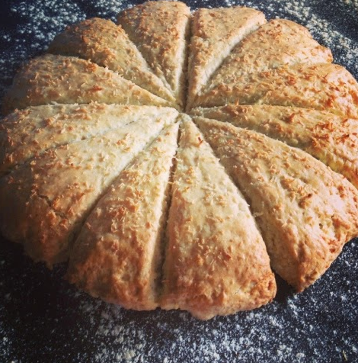
TRINIDAD & TOBAGO COCONUT BAKE

What you need

256g plain flour
3/4 teaspoon salt
2 teaspoons baking powder
2oz margarine
75g desiccated coconut
2 tablespoons sugar
158ml coconut milk

What you do

Preheat oven to 180 degrees

Sieve flour, salt and baking powder into a bowl.
Rub in the margarine, then stir through the sugar and desiccated coconut.
Add the coconut milk, and mix into a firm dough - you may need slightly more or less to get the right consistency
Turn out onto a floured surface and knead very briefly
Using your hands and fingers, press out the dough to a rough circle about 1inch/2.5cm thick and then cut into 10-12 wedges.
Brush the top with some coconut milk and sprinkle with desiccated coconut
Put onto a greased/floured baking sheet and bake till golden brown for about 20-30 minutes.

