

My Life Now and Then

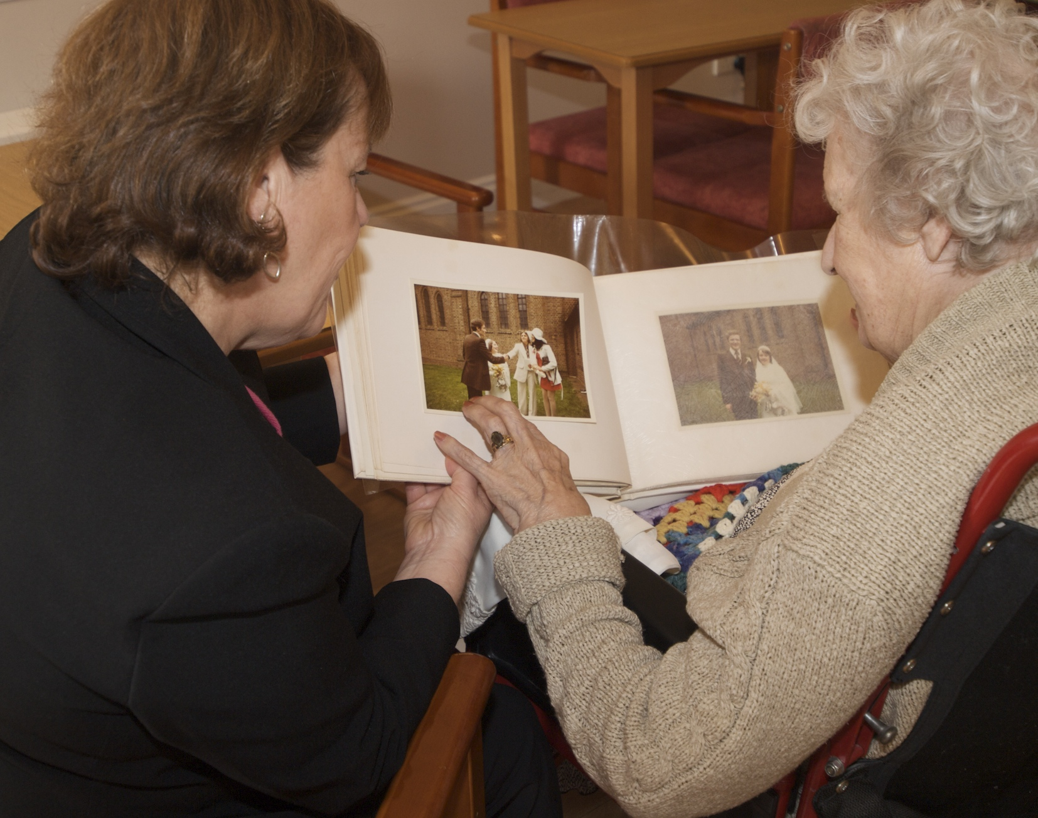

A booklet that will help to capture what is important to me now and things from my past that make me who I am.

Copyright © NAPA 2018
All rights reserved. No part of this publication may be reproduced, distributed, or transmitted in any form or by any means, including photocopying, recording, or other electronic or mechanical methods, unless you are a current NAPA member.

This book belongs to

_______________________________________________________________________________________________
Notes for those helping me to build my new life
Building a relationship with a person being cared for is the first step in being able to support that person to live the life they choose.
Understanding what a person likes or dislikes is important as that information can help to provide the lifestyle that suits them best. If you can introduce this booklet before someone moves home, all the better. It will give you a head start on how they would like things to be when they move in.
You may need to complete this booklet with a relative or carer if the new resident has challenges with communication. If that is the case, please involve the resident as much as possible and look out for responses that might contradict. Sometimes what matters to a resident will differ from that of a relative or friend.
Maintaining your own identity, when living in a communal setting, is known to be a vital ingredient in how well someone settles in and feels at home. Everyone is different, and you must guard against making assumptions or laying out your usual routines as the only way of doing things.
What you learn, and record, in the first few days of a residency, will help you to get to know someone well enough to formulate an initial plan of care that they are happy with. We have offered some ideas and prompts in red text to help you capture important information.
Overtime, you will get to know them better and they will get to know their new home and how they fit into the life on offer there. Plans will be revised; things will change and what you record will grow and develop in tandem with that.
Tread carefully on your first few visits. Take time to get to know the person a bit. Have some typical conversations that you might have with a new neighbour or friend. Diving in with personal questions can be intrusive and may even be seen as rude.
Where we have offered a list of possible answers to a question just circle the relevant ones. We have included these choices as a prompt for you but there is always space for you to write in other important details. Don’t be constrained by the layout, it’s better to write down as much as you need.
Usual Routines
So that we can get things right for you straight away can you tell me what time you like to have your:
Breakfast

Mid- morning snack/drink

Lunch

Mid -afternoon snack/drink

Dinner/Supper

Evening drink

What time do you like to go to bed?

What can we do to help you at bedtime?

What time do you like to get up?

Do you want a wake-up call?

What’s your usual routine in the morning?

What would you like us to help you with?

Keepsakes
Most of us have things or possessions that have some meaning to us that may not matter so much to other people. If you moved in with some keepsakes are you happy to tell me about them and why they are important to you?

Where would you like to keep them?

You might want to take some photos of the keepsakes and add them here.

Things I couldn’t live without

We all have things that are important to us. Things like reading, going out, hobbies, pets all make a difference to how we enjoy life. You might really like a cup of coffee but there are many ways of serving it these days.

Leaving family members aside what are the things that matter to you most?

About living here
I’d like to tell you about the people who live in neighbouring rooms to you. I can introduce you when you feel ready Write in room numbers and names of neighbours

This is the postal address of the home

This is the phone number for friends and family to contact you

This is the email address

This is a photo of the outside of the building
Many people don’t recognise the building so a photo can be a helpful way of connecting someone with their new home and surroundings.

Appearance
We want to make sure that you always look the way you are happy with. You may want to add a photo that shows how you like your hair to be.
For gentlemen

 | Daily | Weekly | On Special Occasions | Other  Helpful notes
To be shaved
Wear a tie
Polish shoes
Hair cut
Trim eyebrows, nose and ear hair
Aftershave
Nail care
Bath
Shower

Do you wear any jewellery or a watch?

Anything else you would like us to know?

Appearance
You may want to add a photo that shows how you like your hair and your make up if any to be
For ladies:
Make up, nails & perfume | Colour/ shade/ fragrance | I like to wear it daily | I like to wear it on special occasions | Other helpful notes
Mascara
Powder/ foundation
Eye shadow
Blusher
Lipstick
Eye liner
Perfume
Nail varnish
Bath
Shower

Hair - Washed and blow dried/ permed/ set/ left to dry naturally.
Do you wear any jewellery or a watch?

Anything else you would like us to know?

Appearance
My favourite clothes for everyday wear (e.g. fashions and colours)

My favourite clothes for a special occasion

How I like to spend my leisure time now
Television & radio (Favourite programmes and time of day to watch/ listen)

Reading (Books, papers, magazines)

Music (type, songs, singers etc) and how do I like to listen to it

Entertainment (Concerts, live performances, cinema)

Dancing (Ballroom, Latin, Line Dancing,)

How I like to spend my leisure time now - continued
Crossword puzzles, Jigsaws, Soduko etc.

Art – Drawing, doodling, painting, colouring, photography etc

Crafts – Knitting, sewing, woodwork, model making etc

Hobbies or other interests – walking, fishing, golf, gardening, bird watching etc

IT and Digital Technology i.e. I pad, mobile phone etc

Other interests
How I like to spend my leisure time now - continued
My idea of a nice ordinary day is:
7am- 10am

10am-12pm

12pm-2pm

2pm-4pm

4pm-6pm

6pm-10pm

10pm - midnight
How I like to spend my leisure time now - continued
Domestic tasks that I like doing

Domestic tasks that I dislike, can’t do or don’t want to do

My idea of an enjoyable trip out is:
Sitting in the garden Local shopping Visiting a cafe Watching the birds
Seeing children play A car ride A bus ride Visiting a museum Theatre trip
Or something else?

If you had a magic wand and could wish for 3 things, what would they be and why?
1

2

3

How I like to spend my leisure time now - continued
I prefer to spend my time Circle the most relevant ones
On my own | Sometimes | Most of the time | All of the time
One to one | Sometimes | Most of the time | All of the time
In small groups  (Less than 6) | Sometimes | Most of the time | All of the time
In large groups  (6 or more) | Sometimes | Most of the time | All of the time

Are you more of a morning or evening person? Describe what you are like at that time of day.

How would your best friend describe you?

How I like to spend my leisure time now - continued
What is your favourite time of year?

What are your ‘pet hates’ - (things you really dislike e.g. bad manners)?

The physical exercise I enjoy now is

The physical exercise I used to enjoy was

How can we support you to access physical exercise now?

My Personal Life
The people who matter to me most now are (note the relationship)

The people who mattered to me most in the past were

Some of us have sensitive issues that we would rather not talk about. For me these are

My Personal Life
Names of spouses or partners

How and when did you meet?

Do you have any children, grandchildren, and great grandchildren? (note as much detail as possible)

Where do they live?

Where we you born and brought up?

My Personal Life - continued
What is your fondest memory?

Do you have any life regrets that you would like to share?

Any life changing experiences that you would like to share? (e.g. War, living overseas)

My Personal Life - continued
Do you have a religion or faith that is important to you?

What church or faith place did you attend (if any) and would you like to attend again if possible?

Hobbies I have enjoyed in the past are

Places I enjoyed visiting on holidays (if any)

The pets I have had (if any)

My Personal Life - continued

What memories do you have of your childhood? i.e. School days, siblings, locations.

Did you work or volunteer – if so, what did you do and where?

Did you belong, or do you still belong to any Clubs, Associations or Societies?

Foods preferences
Food I really like | Food I dislike

Drinks I really like | Drinks I dislike

And finally
Is there anything else that you would like us to know about you?

Your photo pages
We would like to copy, and add in here, any photos that are special to you:



1st Floor, Unit, 1 Fairview Industrial Estate, Raans Road,
Amersham, Buckinghamshire, HP6 6JY
Telephone: 0207 0789375 Email: info@napa-activities.co.uk
www.napa-activities.co.uk

Copyright © NAPA 2018
All rights reserved. No part of this publication may be reproduced, distributed, or transmitted in any form or by any means, including photocopying, recording, or other electronic or mechanical methods, unless you are a current NAPA member.

