NAPA Conference 2020 –

2nd June 2020

In Partnership with The European Reminiscence Network

The Art of

Conversation and Connection -

Arts based reminiscence in activity provision

Conference aim:

This one-day conference will celebrate the importance of conversation and connection. Delegates will be given the opportunity to explore practical approaches to enable conversation, connection and self-expression through arts-based reminiscence. Delegates will also be encouraged to connect with each other.

Learning outcomes: Participation in this conference will enable delegates to:

• Recognise the role of arts based reminiscence in enabling conversation, connection and self expression

• Identify methods for improved conversation, connection and self expression

• Describe the role of arts based reminiscence in the provision of person centred care

• Plan person centred arts based reminiscence activities for people living with care and support needs

Audience:

This conference is suitable for all those providing care, support and activity to people with care and support needs. Managers, Clinicians, Therapists, Nurses, Care staff, Activity providers, Catering professionals, Commissioners and Arts Practitioners are welcome.

Speakers to include:

Pam Schweitzer, Hilary Woodhead, Grace Meadows, Isobel Jones & others

Venue:

The University of Greenwich, London

Supported by 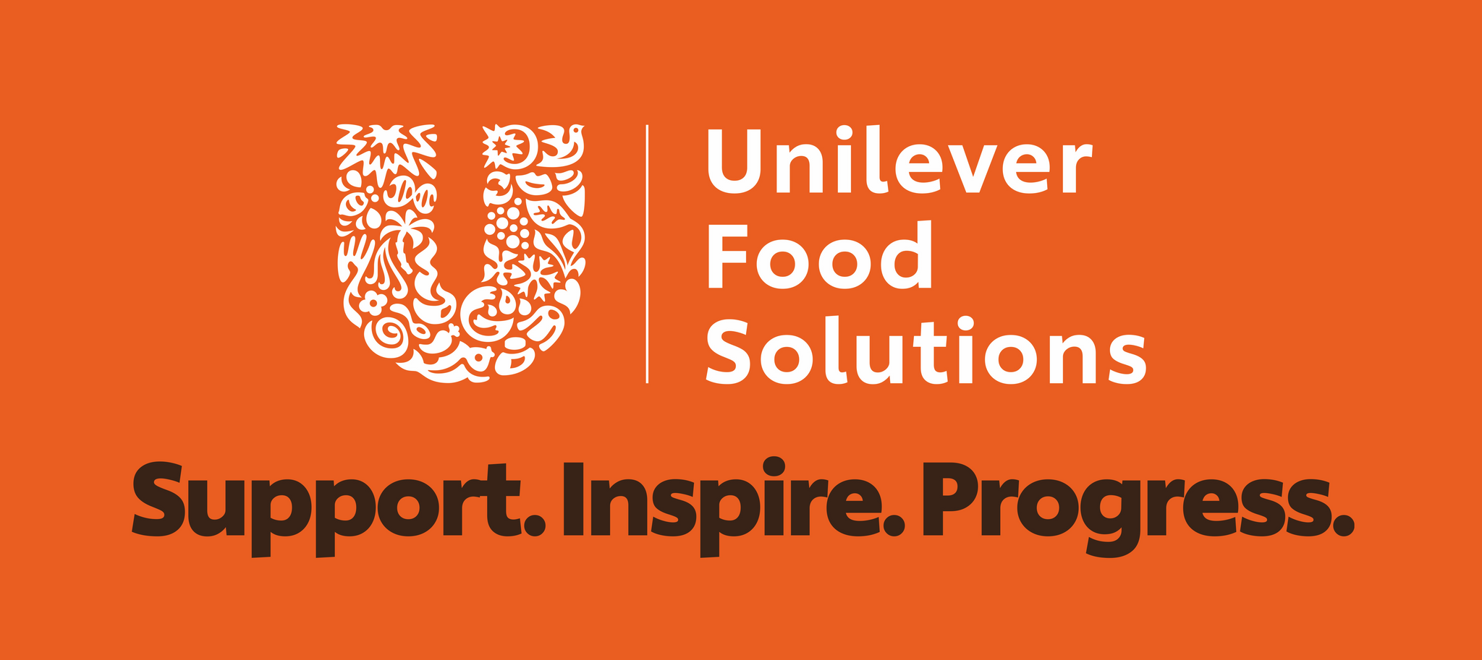 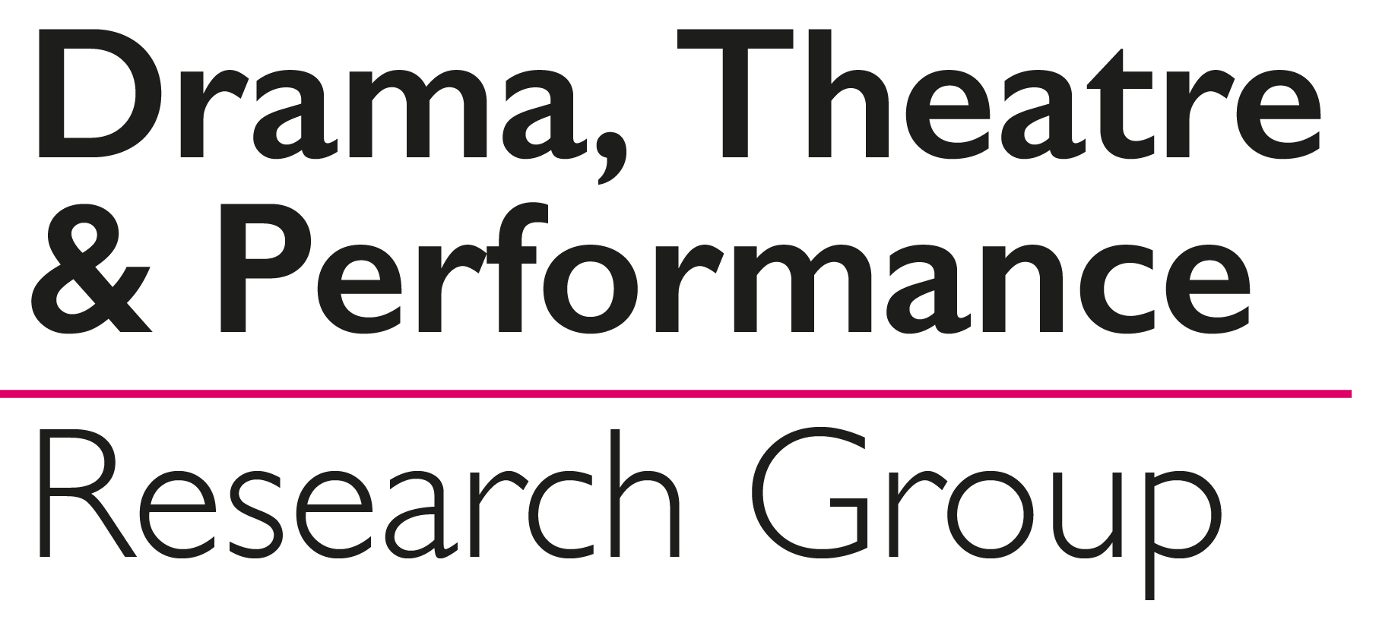

National Activity Providers Association 1st Floor, Unit one, Fairview Industrial Estate, Raans Road, Amersham, HP6 6JY

T: 020 7078 9375 F:01494 726752 Email: info@napa-activities.co.uk [www.napa-activities.co.uk](http://www.napa-activities.co.uk)

Application form

NAPA Conference June 2nd 2020

Please complete the form and send it to NAPA (Email, Fax or post); you will be invoiced for the total number of delegates at the member rate (£125) or non-member rate (£200**) per delegate. Your place is only guaranteed upon receipt of payment. Your ticket will be emailed to you once we have received payment. *Please see terms & conditions below. ** Includes 1 years NAPA membership*

|  |  |  |
| --- | --- | --- |
| Care setting/ individuals name |  | |
| Membership number: |  | |
| Full address: |  | |
| Invoicing address if different to above: |  | |
| Purchase order number if applicable: |  | |
| Email address for invoice: |  | |
| Number of delegates | |  |
| Names | |  |
| Email address for tickets | |  |
| Dietary Requirements | |  |

Closing Date: 24th April 2020 Terms & Conditions

* Payment is in advance of attendance
* The delegate is invoiced on receipt of application and confirmation of place and ticket are only issued upon payment
* Cancellation with full refund is available if you cancel no later than 18 days before the date of the conference. Thereafter no refund is available
* Each training session needs a minimum of 15 delegates, if this number is not reached the Masterclass will be cancelled and we will issue a refund for the places booked. NAPA will not refund any travel or accommodation costs. You will be notified at least one month before the date of the training if it is to be cancelled
* You can request to transfer your place to a colleague which avoids loss of the fee, if within 18 days of the date of the conference