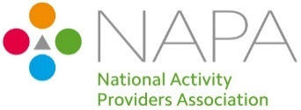
Join up now for NAPA membership!
To join send your completed form to membership@napa-activities.co.uk and we will raise an invoice which will be sent directly to the email address you provide below. Alternatively, you can visit our online shop www.napa-activities.co.uk.
If your application is for more than one care setting, please email membership@napa-activities.co.uk, (for every care setting with a different address a separate membership will be required.)

*Please circle/highlight which membership you require
I would like to apply for the following membership: | 12 months membership - £90.00  (Cost per setting) | 24 months membership -  £140.00  (Cost per setting) | 36 months membership -  £190.00  (Cost per setting)
*Membership will start from the 1st of the following month after payment has been received.

Care Group/Organisation*:
Type of Service: *Delete as appropriate | Care Home, Home Care, Hospice Care, Extra Care Housing, Hospitals, Care of Older People, Care of people living with dementia, Care of Adults with Physical Disabilities, Care of Adults with learning Disabilities, End of Life Care
Name of Care Setting*:
(* these will appear on your membership certificate)
Address (including postcode):
Telephone Number:
Managers Email Address:

Email Address for invoice:
(all invoices will be emailed)
Do you want to receive NAPA News, please enter the email address here:
Reference/PO number:
(If Applicable)
Invoice address if different to above
(If Applicable)
How did you hear about NAPA? | .

By signing this application form you are agreeing to uphold the vision and values of NAPA.

Signed_________________________________ Name__________________________________ (Please Print)

Job title______________________________ On behalf of _________________________ (organisation/care setting)

Date: ___________________________

NAPA Membership Benefits

NAPA is an umbrella membership organisation that connects, signposts, encourages and motivates anyone with an interest in lifestyle, well-being, life, love and laughter in the care sector.
Our aim: Every care and support setting to be full of life, love and laughter.
We value: The uniqueness of every person and their right to a meaningful conversation every day. The right to person-centred meaningful engagement with choice and control over how they spend their time.
Activity provision, which is respectful, creative, innovative and fun supported by skilled staff.
By being a member of NAPA, you will receive a range of benefits. For example:

For the individual or team directly responsible for activity provision
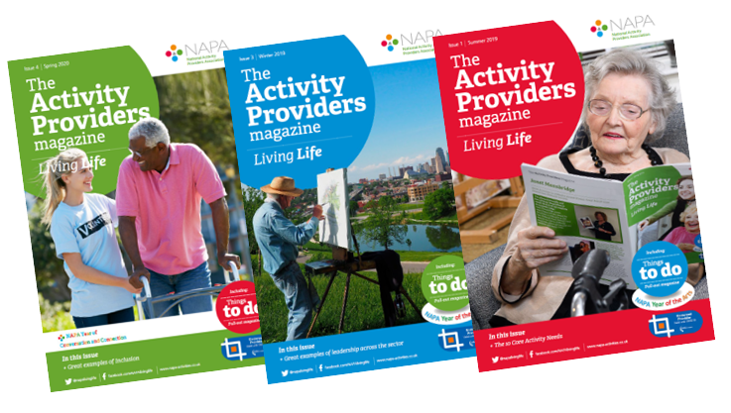
- Quarterly magazine with pull-out section called ‘Things to Do’ that can be ring bound to build a resource file of ideas.
- Telephone Helpline managed by skilled activity providers which is available 07.30 - 16.00 Monday - Thursday.
- Resources section on the Website with articles, research and useful information.
- NAPA e News every 2 weeks with updates on events and news across the care sector.
- Closed Facebook group for exchanging ideas and offering support.
- Entry to the NAPA Member Awards
- One Free RQF qualification in Supporting Activity Provision Level 2 course - Groups that have 50 or more care settings will receive one free course per 50 care settings.

- One Free RQF qualification in Supporting Activity Provision Level 2 course - Groups that have been with us for more than 5 years will receive one free course per 20 care settings, every 5 years.
- Free Induction eLearning course to all NAPA members and their staff, e.g. if you have 300 staff, they will all be able to access the e learning for free.
- 60% discount on nationally recognised, Skills for Care Endorsed training leading to formal Distance Learning RQF qualifications in Supporting Activity Provision at Level 2 and Providing Activity Provision at Level 3.
- 60% discount and priority booking on NAPA Conferences and Open Training days.

For the Care Home management
- Membership Certificate to display in Reception.
- The Care Quality Commission Provider Information Return form asks for details of involvement with national bodies supporting best practice - NAPA is listed.
- 60% discount on the NAPA Independent Audit service.
- 60% discount on Consultancy services and bespoke Training days.
- For Corporate level management
- Discounted Consultancy to support strategic planning.
- Discounted External Audits to compare services.
- Opportunities to tailor NAPA publications for in house use.
- Use of the NAPA members logo on your website or company stationery.

