NAPA Membership Benefits
NAPA is an umbrella membership organisation that connects, signposts, encourages and motivates anyone with an interest in lifestyle, well-being, life, love and laughter in the care sector.
Our aim: Every care and support setting to be full of life, love and laughter.
We value: The uniqueness of every person and their right to a meaningful conversation every day. The right to person-centred meaningful engagement with choice and control over how they spend their time.
Activity provision, which is respectful, creative, innovative and fun supported by skilled staff.
By being a member of NAPA, you will receive a range of benefits. For example:

For the individual or team directly responsible for activity provision
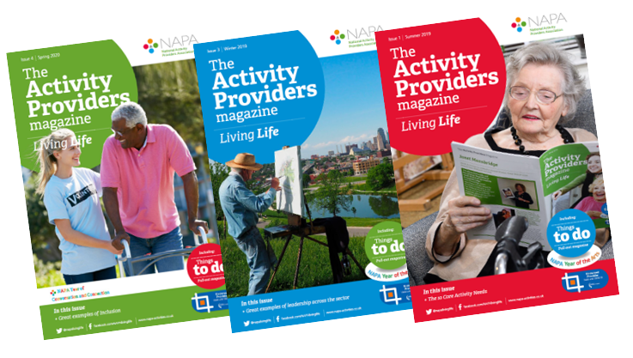
- Quarterly magazine with pull-out section called ‘Things to Do’ that can be ring bound to build a resource file of ideas.
- Telephone Helpline managed by skilled activity providers which is available 07.30 - 16.00 Monday - Thursday.
- Resources section on the Website with articles, research and useful information.
- NAPA e News every 2 weeks with updates on events and news across the care sector.
- Closed Facebook group for exchanging ideas and offering support.
- Entry to the NAPA Member Awards
- One Free RQF qualification in Supporting Activity Provision Level 2 course - Groups that have 50 or more care settings will receive one free course per 50 care settings.

- One Free RQF qualification in Supporting Activity Provision Level 2 course - Groups that have been with us for more than 5 years will receive one free course per 20 care settings, every 5 years.
- Free Induction eLearning course to all NAPA members and their staff, e.g. if you have 300 staff, they will all be able to access the e learning for free.
- 60% discount on nationally recognised, Skills for Care Endorsed training leading to formal Distance Learning RQF qualifications in Supporting Activity Provision at Level 2 and Providing Activity Provision at Level 3.
- 60% discount and priority booking on NAPA Conferences and Open Training days.

For the Care Home management
- Membership Certificate to display in Reception.
- The Care Quality Commission Provider Information Return form asks for details of involvement with national bodies supporting best practice - NAPA is listed.
- 60% discount on the NAPA Independent Audit service.
- 60% discount on Consultancy services and bespoke Training days.
- For Corporate level management
- Discounted Consultancy to support strategic planning.
- Discounted External Audits to compare services.
- Opportunities to tailor NAPA publications for in house use.
- Use of the NAPA members logo on your website or company stationery.

