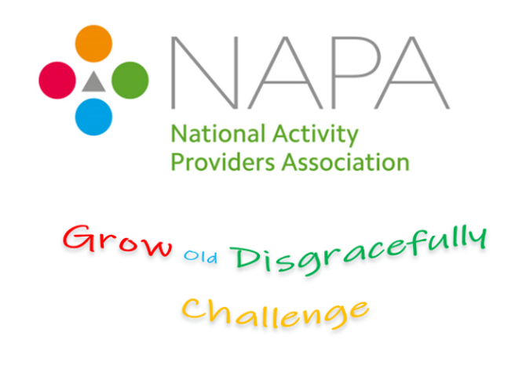
The Grow Old Disgracefully Challenge

Do you know an older person who is - Growing Old disgracefully?

We are looking to celebrate a person who is living life to the full and fulfils the description of ‘growing old disgracefully’.

Do you know an older person who:

- inspires you with their zest for life?
- is living life with an outrageous or fabulous twist?
- has always wanted to do something that defies expectations, but hadn’t had the chance to make it happen, until you came along?

Have YOU helped someone achieve their wish to grow old disgracefully?

We want to hear from you!

Write and tell us in no more than 500 words why you have entered this person into the challenge.

Please include photographs of the person achieving their wish or dream – please seek consent.
Email your entry and the contact form to project@napa-activities.co.uk
There is no limit to the number of nominations you can make. Anyone can make a nomination- managers, staff, residents, relatives or visitors.

Closing date for entries: 5pm on the 20th July 2020.
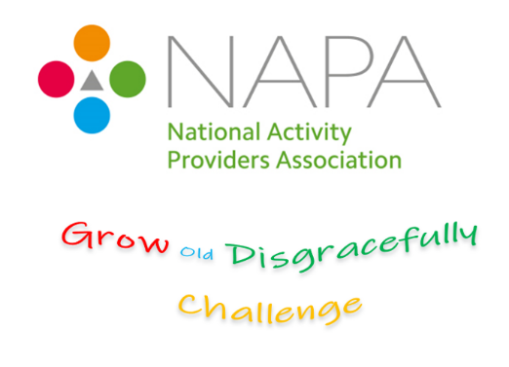
For office use only

Nomination number:

Photo consent Y/N

Please fill in your contact details and attach it to your entry
Name of Care Setting and Organisation (if applicable):
NAPA Membership Number:
*Submissions are open to NAPA members only, please contact the office if you do not know your membership number*

Name of person to contact should this entry be shortlisted:

Full postal address:

Postcode:

Email address:

Your Email address:

Telephone number:

Your Email address:

Closing date for entries: 5pm on the 20th July 2020.

Entries received after this time will not be counted.

Please send this form and your challenge entry to:
NAPA, 1st Floor, Unit One, Fairview Industrial Estate, Raans Road,
Bucks, HP6 6JY
Telephone: 0207 078 9375 Fax: 01494 726752 Email: project@napa-activities.co.uk

Name of Person who is “Growing old Disgracefully”: Please print

