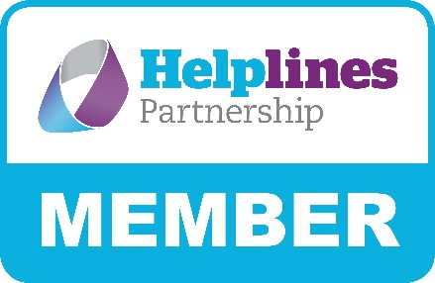
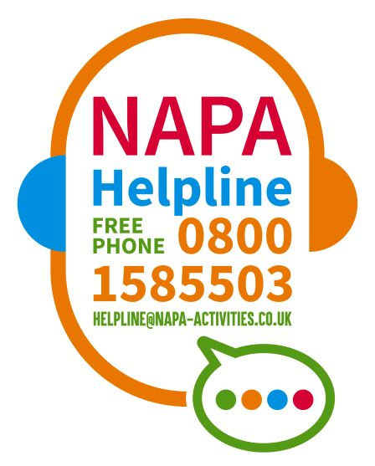

Dear Manager,

NAPA Helpline – How can it help managers?

Although NAPA have offered a helpline service for several years, funding from the Rayne Foundation has enabled them to provide a freephone number, making the service completely free.

The funding has also allowed them to engage me, as helpline manager to oversee the development of the helpline for twelve months.

You can learn more about how the helpline can help you, as a manager, on NAPA’s Helpline Podcast, where you will hear Hilary Woodhead, Executive Director, and me discussing the value of the helpline to managers and their staff teams. Click here to watch the Podcast.

To introduce this number and help you to launch it in your home we have put together a pack, which we hope will help you to do this. The pack contains:

- Printable poster to put in the staffroom
- Printable cards (postcard and business card size) so your staff can always carry the number with them
- Reasons why the helpline can be valuable to managers
- Tips on how staff can improve their working day
- Booklet from MIND: for line managers – Wellness Action Plans

The helpline is here for you as well as your team and we look forward to hearing from you.

I would greatly appreciate any feedback on how the helpline helps your service, or how you think it can be improved. I will be in touch in due course to gather your views but do get in touch at any time if you have specific feedback.

Yours sincerely,
Sylvia
Sylvia Cowleard
NAPA Helpline Manager

